Digital Architecture Framework


Digital Architecture
Framework
DAF v. 6.3
Rev. 15
Aug 2026

Contents
About Digital Architecture Framework (DAF) 3 | Extension Domains 16
License 5 | Viewpoints and Views 17
Project 6 | DAF Concepts Organized in Viewpoints 19
Installation 6 | Views and work products 20
Concepts 8 | Relationships 21
From Reality to Abstraction 8 | Relationship Strategy 22
From the Model to a View 8 | Detailed Documentation 23
DAF Metamodel 11 | DAF Concepts Overview 23
Example Model Instance 12 | DAF Relationship Types 33
Layers 14 | DAF Relationships Quick link 41
Enterprise Architecture 14 | Visual Characteristics of some DAF stereotypes 48
Solution Architecture 14 | Appendices 50
Design Architecture 15 | Stereotypes and Tagged Values 50
Domains 15 | Model Checks 64
Business 15 | 84DAF COLORS 68
Data 15 | RGB Colors 68
Application 15 | HEX Colors 69
Technology 16

About Digital Architecture Framework (DAF)
The Digital Architecture Framework (DAF), formerly known as "Delta Architectural Framework," is a set of modeling tools for Digital Engineering aiming to enable collaboration between roles such as Enterprise Architects, Solution Architects, and Business Analysts in designing the enterprise by creating high-quality models that can be transformed into artifacts such as code and documentation.
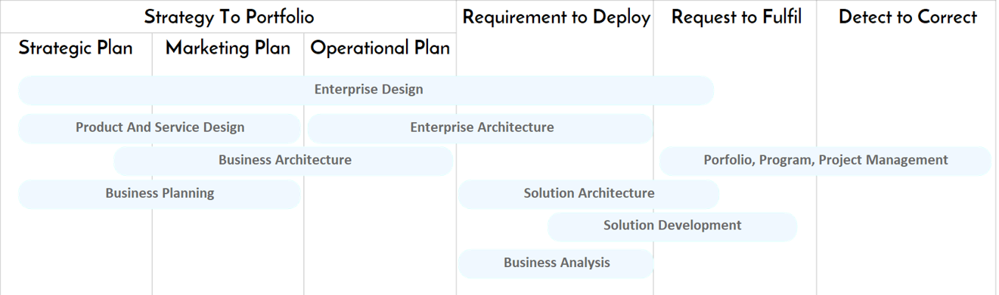
Figure 1: Value Streams covered by DAF
The diagram shows the classic gaps between strategy, design, and execution. DAF may accelerate the delivery of projects by supporting collaboration of different roles and by creating traceability between strategy and execution. In fact, it provides the metamodel to close these gaps, ensuring that strategic plans are directly reflected in architectures, architectures are transformed into solutions, and solutions generate tangible deliverables with traceability back to strategy.
The DAF meta-model is based on industry standards such as UML, ArchiMate, TOGAF, RUP, SPEM and best practices for requirement management, and offers a baseline of more than 50 concepts and properties that can be customized to meet specific needs. While DAF can be used on its own, it is not intended to represent a new standard but rather serves as an accelerator that allows for quick tailoring of existing standards.

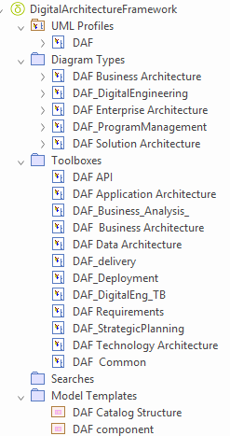
Figure 2: Content of the DAF MDG
DAF is currently implemented as MDG technology in Sparx Enterprise Architect, including:
- UML profile
- A set of customized icons
- Shape scripts
- multiple Toolboxes, organized by roles
- Custom diagrams, organized by roles
- Model patterns, accelerating the creation of DAF diagrams.
- Model Template with the structure of DAF Catalogs
- Quick linker
- A set of 100+ diagram examples showing how to use DAF to cover Enterprise Architecture, Solution Architecture, Design Architecture and Business Analysis. Those examples include all the diagrams in the TOGAF 9.1 specification.
- A structure based on TOGAF to host an enterprise repository
- A set of scripts, performing Model-to-Model (M2M) transformations
- A set of rules for model validation implemented in the EA Validator

License
- DAF is Open Source, released under the Creative Commons
- Digital Architecture Framework © 2026 by Giu Platania is licensed under Creative Commons Attribution 4.0 International
- This license requires that reusers give credit to the creator. It allows reusers to distribute, remix, adapt, and build upon the material in any medium or format, even for commercial purposes.

Project
DAF is maintained in GitHub: Digital Architecture Framework GitHub repository

Installation
- Obtain the DAF MDG file: Ensure you have the XML file defining the DAF MDG Technology from the repository Digital Architecture Framework releases. This file contains the definitions for stereotypes, toolboxes, profiles, and diagram types.
- Save the file to an accessible directory on your computer.
- Launch Sparx Enterprise Architect.
- Open or create a project where you want to use the DAF MDG Technology.
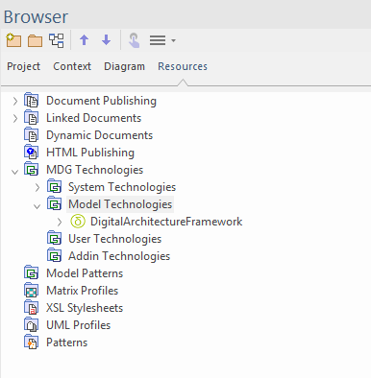
- In the browser, open the tab Resources and navigate to MDG technologies> Model Technologies, right click and select Import Technology.
- Locate and select the daf.xml file
- Select import to Model
- Click OK to load the MDG Technology into Sparx EA.
- Optional: Enable the DAF MDG Technology
  - Go to Specialize > Technologies > Manage Technologies.
  - In the list of available MDG Technologies, find "DAF" and check the box to enable it.
  - Click Close to save your settings.
- Suggested: set your perspective focus on DAF
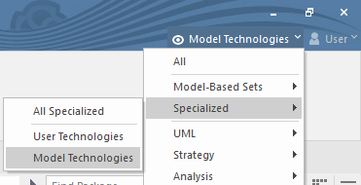
- Test a DAF diagram
  - Create a new diagram
  - Select one DAF Diagram from the options
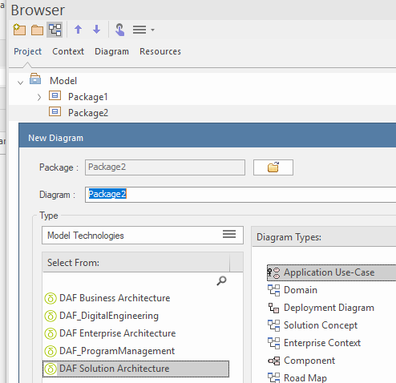

Concepts

From Reality to Abstraction
DAF is a metamodel (M2) that describes the elements of a Model (M1) that is, in turn, an abstraction of a real system (M0).

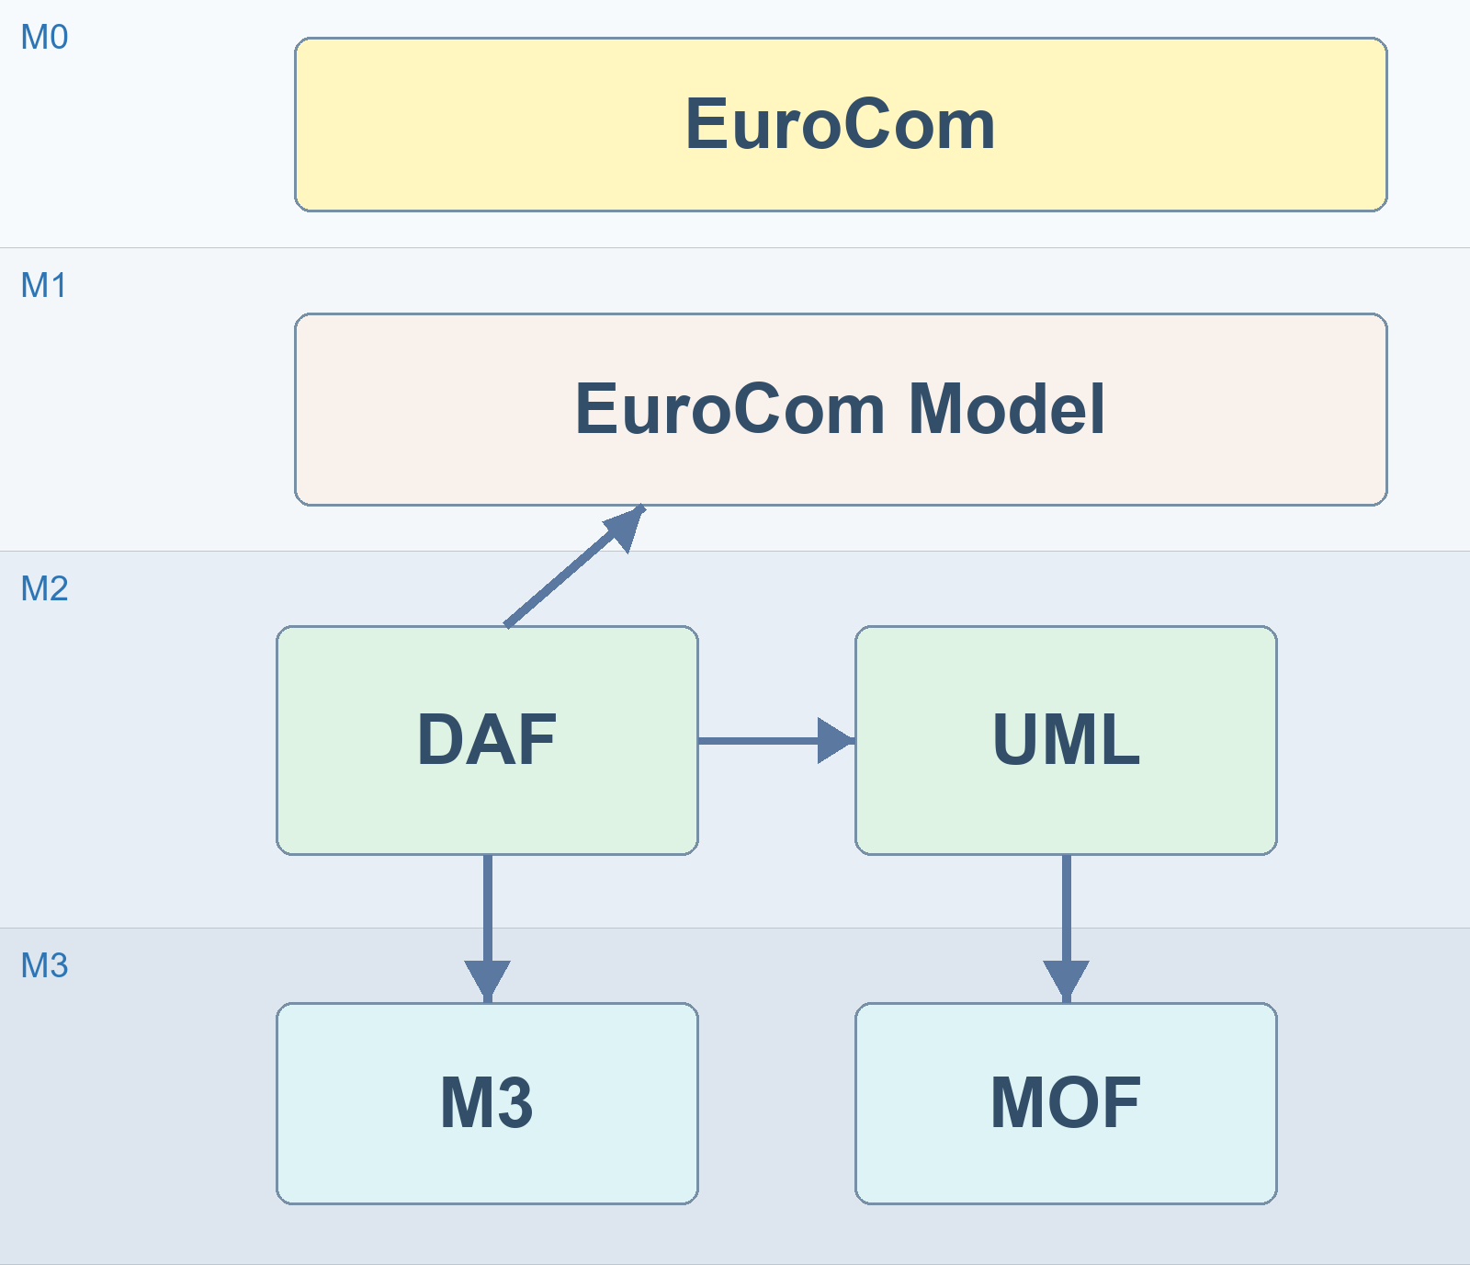
Figure 2: The hierarchy in this diagram follows the MDA principle of abstraction, where each level (M0 to M3) adds structure and abstraction to the level below, ensuring a consistent and scalable modeling approach.
- M0: EuroCom: The M0 layer represents the real-world organization or domain of interest, here as "EuroCom." This is the concrete instance of the domain that the models aim to represent, analyze, and improve. It consists of actual data and entities in the operational environment.
- M1: EuroCom Model: The M1 layer contains the model of the M0 domain. In this case, the "EuroCom Model" represents an abstraction of the EuroCom organization, describing its structure, behavior, or other aspects at a higher abstraction level. The M1 model acts as a blueprint that specifies how the M0 system is represented.
- M2: DAF and UML: The M2 layer defines the metamodels that describe the structure and semantics of the models in the M1 layer The arrow from DAF to UML indicates influence, highlighting how DAF integrates concepts from UML.
- M3: M3 and MOF: At this level, the fundamental rules and concepts for defining modeling languages are established. The M3 layer represents the meta-metamodels that describe the foundation for defining metamodels like UML or DAF. M3 is a custom meta-metamodel that can describe DAF or other metamodels. M3 is used instead of MOF (Meta-Object Facility): A standard meta-metamodel defined by the OMG to provide a formal foundation for modeling languages like UML.

From the Model to a View
There is a formal way of separating the idea of “one model” from the way we look at it, develop it, and communicate it.
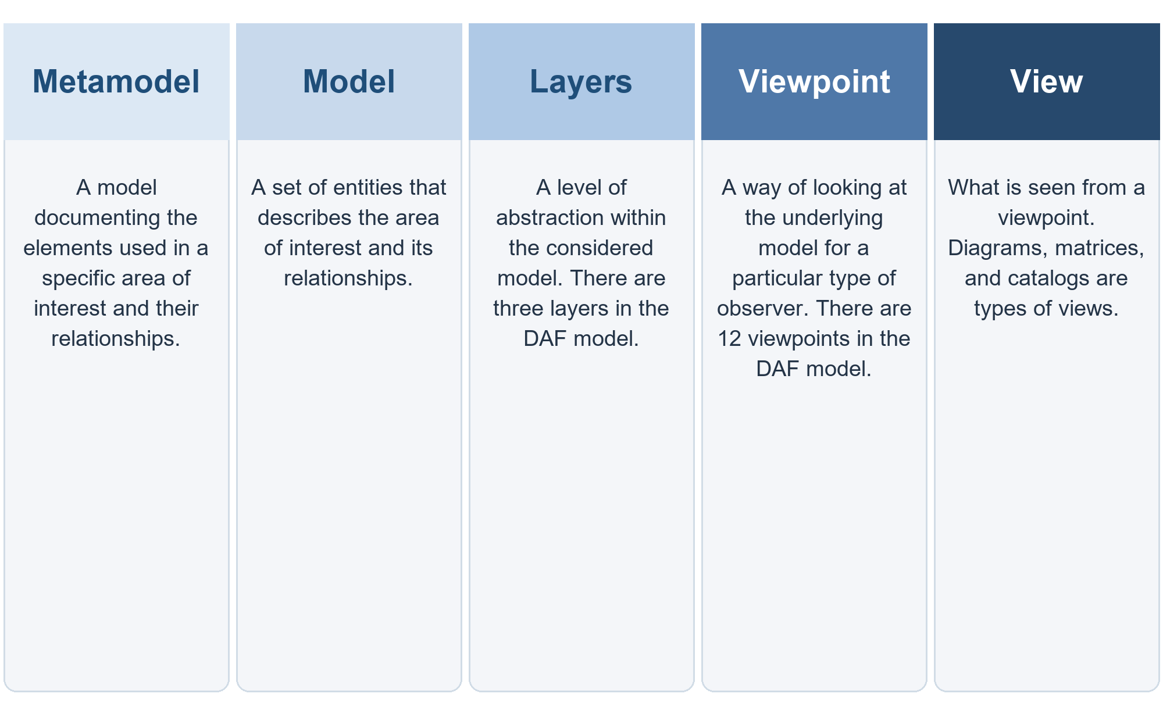
The Digital Engineering approach aims to enable the separation of concerns across different models, metamodels and viewpoints, allowing for a more flexible, maintainable and understandable representation of the system, making it possible for different stakeholders to focus on the aspects of the system that are relevant to them.

A "metamodel" is a model … of a model, which defines the structure and constraints of the models that conform to it. It describes the concepts, properties, and relationships that a model can contain, as well as the constraints and rules that apply to them. Metamodels are often expressed in formal languages, such as MOF or eMOF.

The concept of a "model" refers to a representation of a system or part of it in a specific format that adheres to the metamodel (e.g. UML or ArchiMate). These models can be used to define the architecture of a system. The ISO/IEC/IEEE 42010 standard defines "architecture" as "the fundamental organization of a system, embodied in its components, their relationships to each other and the environment, and the principles guiding its design and evolution."
.
A "Model Layer" is a set of models that conform to a specific metamodel and are used to represent a specific aspect of the system being modeled. For example, one model layer could be used to represent the logical architecture of the system, while another could be used to represent the physical deployment of the system.
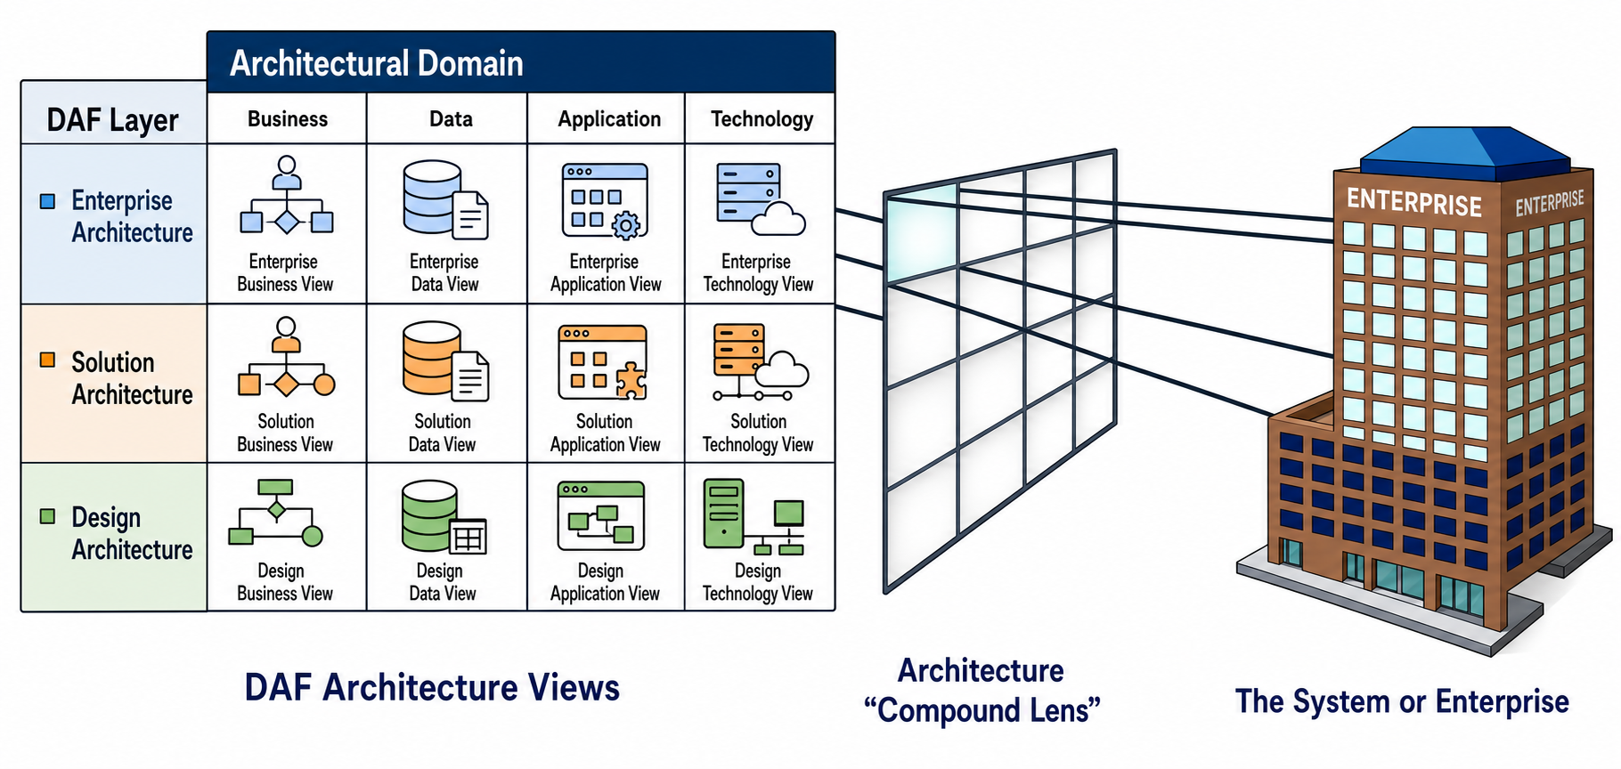Figure 3: Relation between IT view and Enterprise

A "Viewpoint" is a set of views that have a common purpose or perspective. It can be related to specific domain, such as security or performance, and defines a specific set of views and model elements to be used to capture the relevant information from the system.

A "View" is a perspective or a specific part of a model that is relevant to a particular audience, such as stakeholders or developers. Each view provides a specific representation of the system, highlighting different aspects of the system and omitting the less important details.

DAF Metamodel

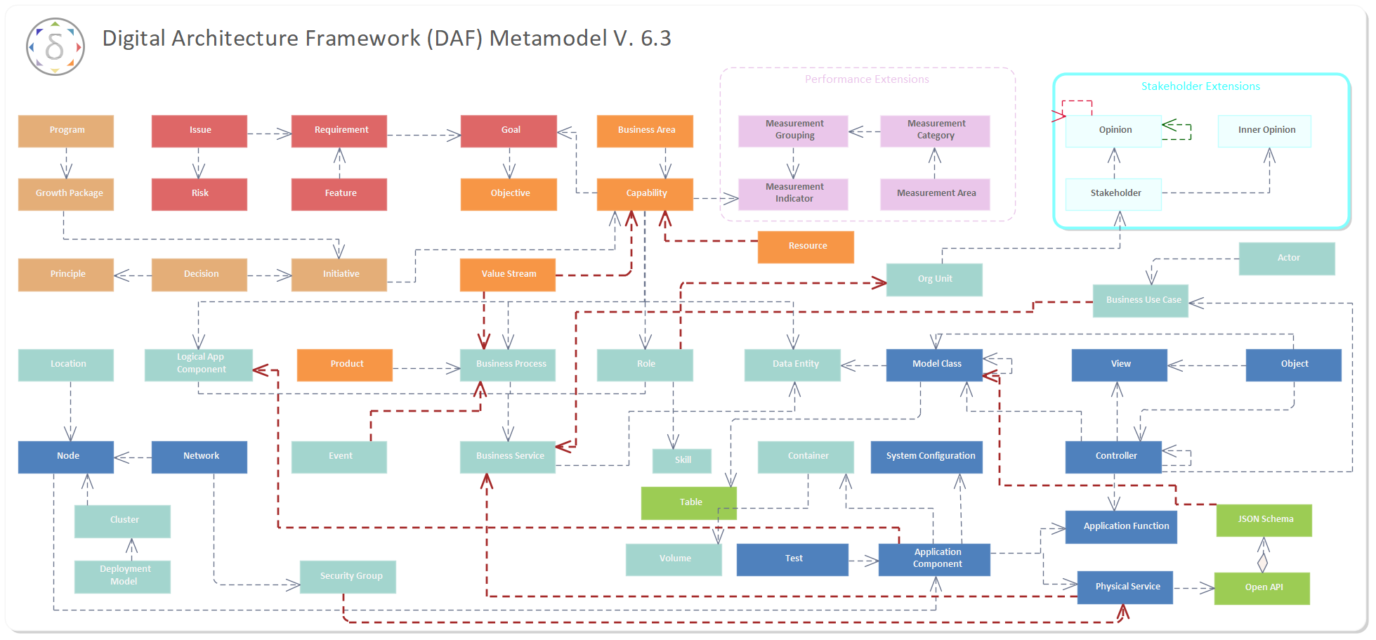
Figure 4: DAF Metamodel
The DAF Metamodel supports Enterprise Architecture, Solution Architecture, Design Architecture and more. See the description of the DAF layers below.

Example Model Instance
Each element of the Metamodel can be instantiated into a concrete model’s element.
The following diagram shows an example of a DAF Metamodel instance
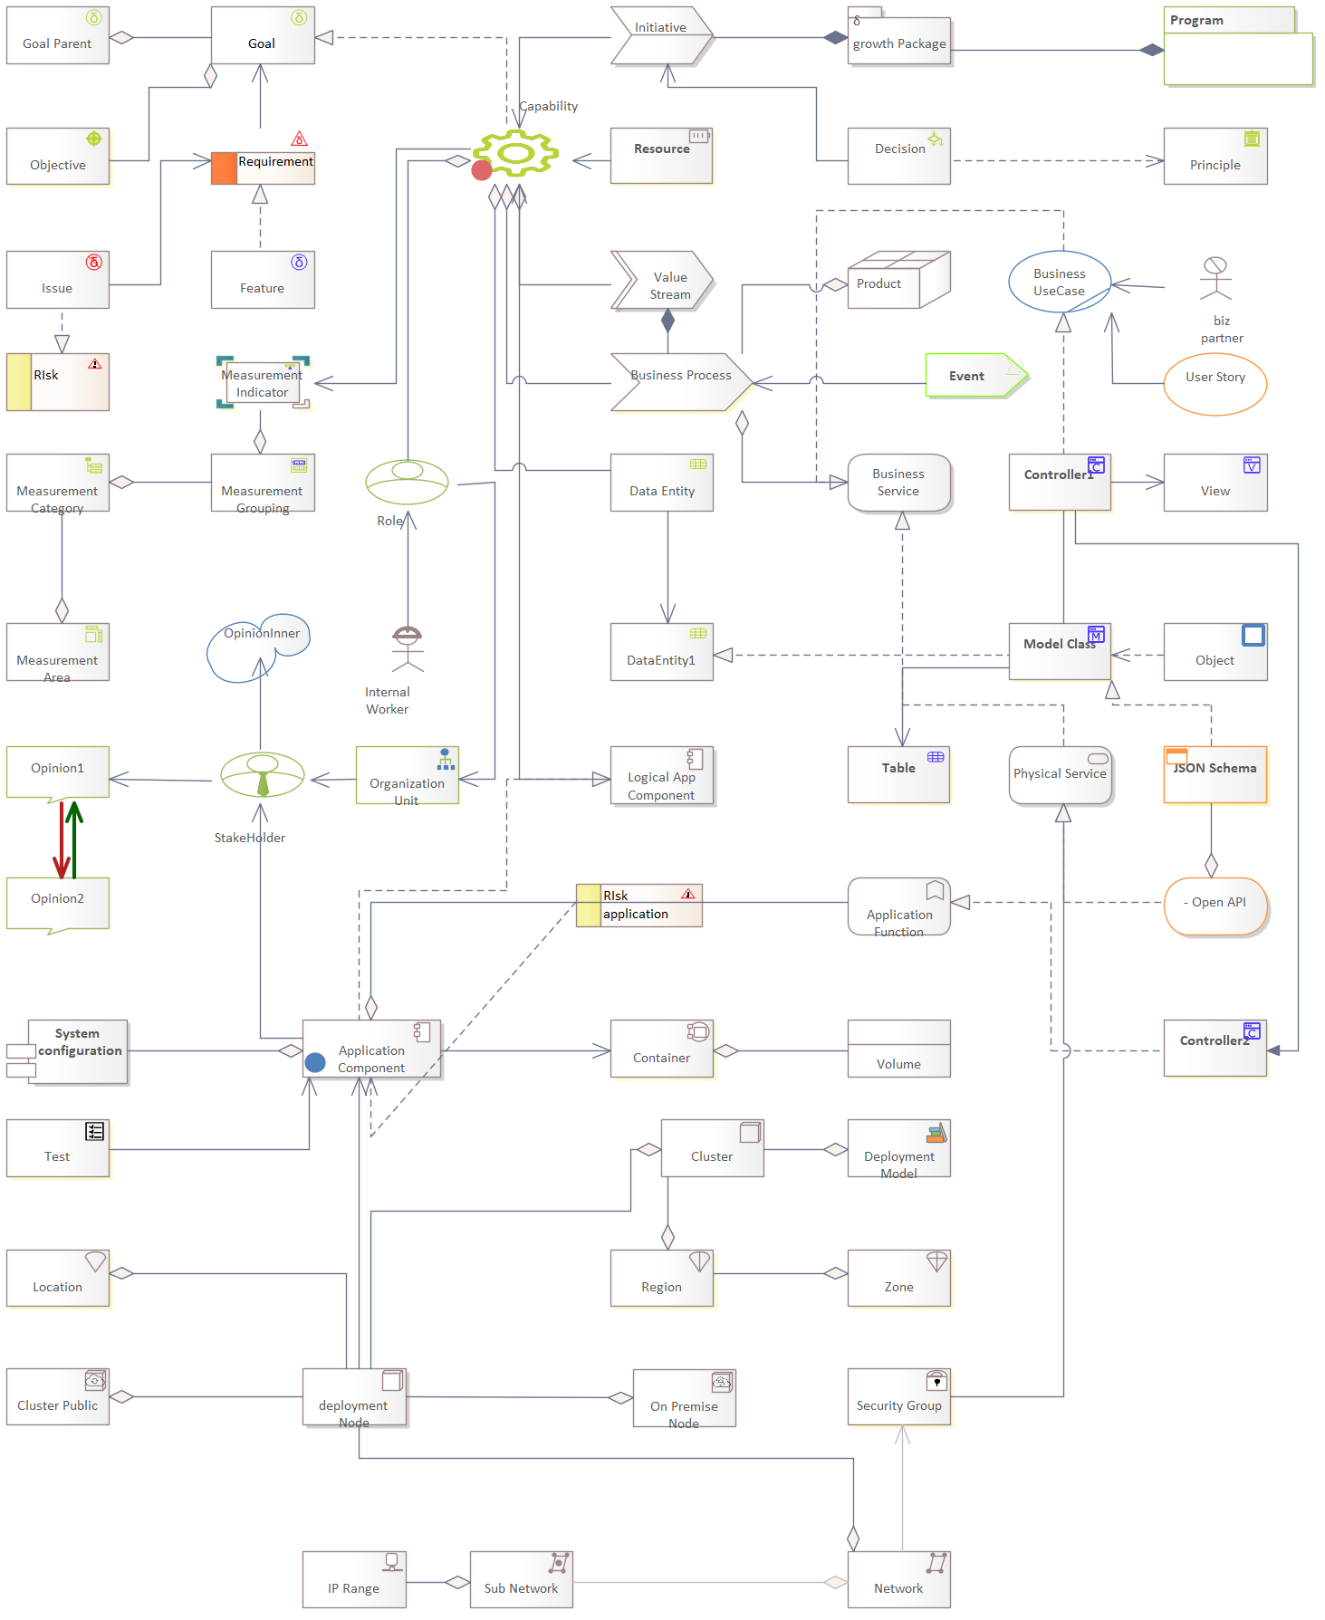
Figure 6: DAF 6.3 Example Instance
DAF supports the Sparx EA quick linker that helps modelers to create only valid connections. Models can be also validated using the Checker (see below)
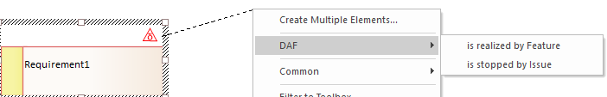

Layers
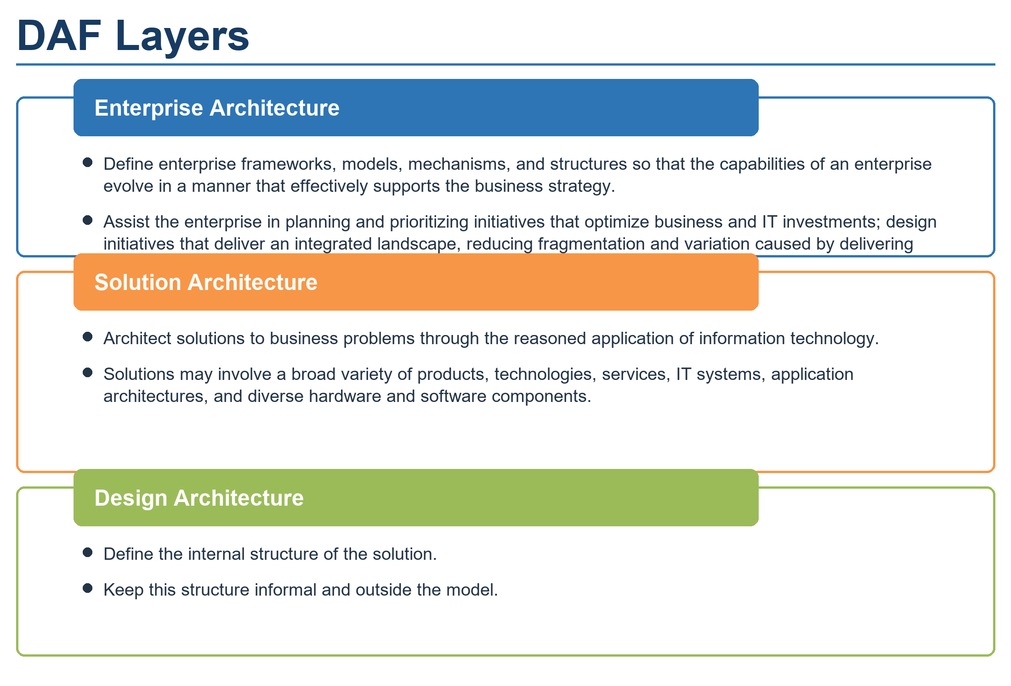
Figure 7: DAF Layers
DAF is divided into three levels of abstraction: Enterprise, Solution, and Design Architecture. Each of these levels is further broken into specific domains (see below).

Enterprise Architecture
- This Layer covers logical considerations. Viewing the system in terms of roles participating in processes by using resources: Who, How, and What. It corresponds to the Computational Independent Model (CIM).
- It defines enterprise frameworks, models, mechanisms, and structures so that capabilities of an enterprise evolve in a manner that effectively supports the business strategy
- Assisting the enterprise to plan and prioritize initiatives that optimize business & IT investments; designing initiatives that deliver an integrated landscape to reduces the fragmentation and variation that is the natural result of delivering solutions in an autonomous manner.
- The Enterprise Architecture level focuses on the logical considerations of the system, such as the roles, processes, and resources involved. This abstraction level helps the enterprise plan and prioritize initiatives that optimize business and IT investments, and design initiatives that deliver an integrated landscape to reduce fragmentation and variation.

Solution Architecture
- The Solution Architecture layer connects to the previous and translates the logical model into an operational one by describing the elements of the system that supports the business and assigns processes to them.
- It aims as definition of solutions to business problems through the reasoned application of Information Technology.
- They may involve the application and integration of a broad variety of products, technologies and services, various IT systems and applications architectures, and diverse hardware and software components.

Design Architecture
- This Layer designs the components of the solution, taking in account the different supporting technologies.
- The definition of the internal structure of the solution.
- Generation of Code

Domains
The abstraction layers are further organized into domains. A domain represents a vertical organization of concepts, incorporating related concepts at different levels of abstraction. These domains serve to organize and structure the various components and elements of the architecture in a logical and meaningful way.
The foundational domains in DAF are:

- Business
- Data
- Application
- Technology
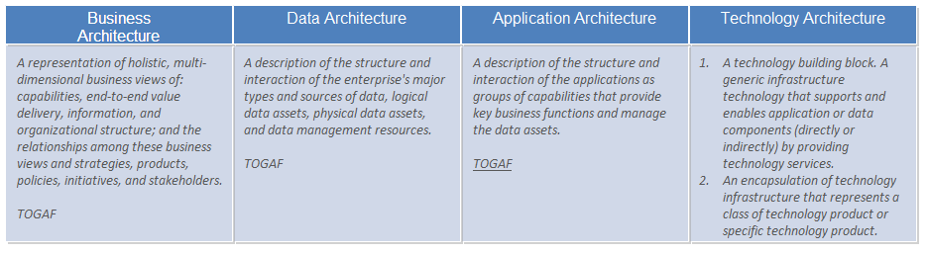
Figure 5: Foundational DAF domains, inspired by TOGAF

Business
This domain covers the business-specific concepts, such as business processes, services, and functions that an organization offers to its customers. It focuses on understanding the business objectives and strategies, and how the IT solutions can support those goals.

Data
This domain covers information-related concepts, such as data models, data architecture, data governance, data security, and data management. It’s focused on understanding the organization's data requirements, and how the IT solutions can support data management and access.

Application:
This domain covers software-related concepts, such as application architecture, application integration, and service-oriented architecture. This domain is focused on understanding the organization's application requirements, and how the IT solutions can support application deployment and management.

Technology
This domain covers technology-related concepts, such as infrastructure, network, security, and cloud. This domain is focused on understanding the organization's technology requirements, and how the IT solutions can support infrastructure and technology management.

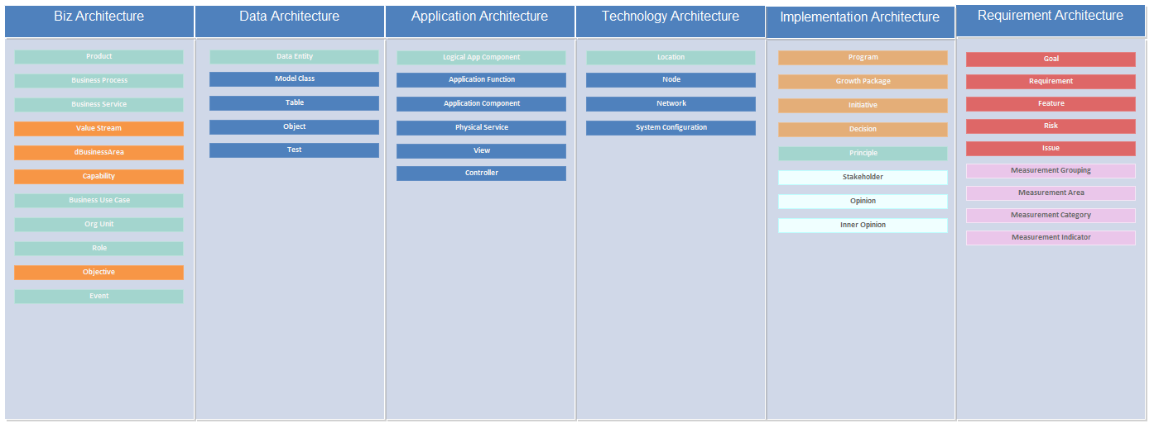Figure 6: Domains and concepts of DAF

Extension Domains
Additional Domains can be also used with DAF when required.
Those include Strategy, Implementation and Requirements.

Viewpoints and Views
The intersection of a Layer and Domain creates a Viewpoint, addressing specific concerns about a system of interest. A Viewpoint is a way of looking at a system from a specific perspective and addressing specific concerns related to that system. In the context of DAF, a Viewpoint is the intersection of a Layer and a Domain.

Each Layer, such as Enterprise, Solution, and Design Architecture, provides a different level of abstraction and focus, while each Domain, such as Business, Data, Application, and Technology, represents a specific area of concern. By intersecting these two concepts, a Viewpoint is created that addresses specific concerns of the system-of-interest from the perspective of that Layer and Domain. For example, a Business Viewpoint within the Enterprise Layer would focus on the logical considerations of how the system supports the business strategy, while a Data Viewpoint within the Design Layer would focus on the design of the data components of the solution.

The use of Viewpoints allows for a more targeted and granular approach to analyzing and designing a system, as different stakeholders can look at the same system from different perspectives.
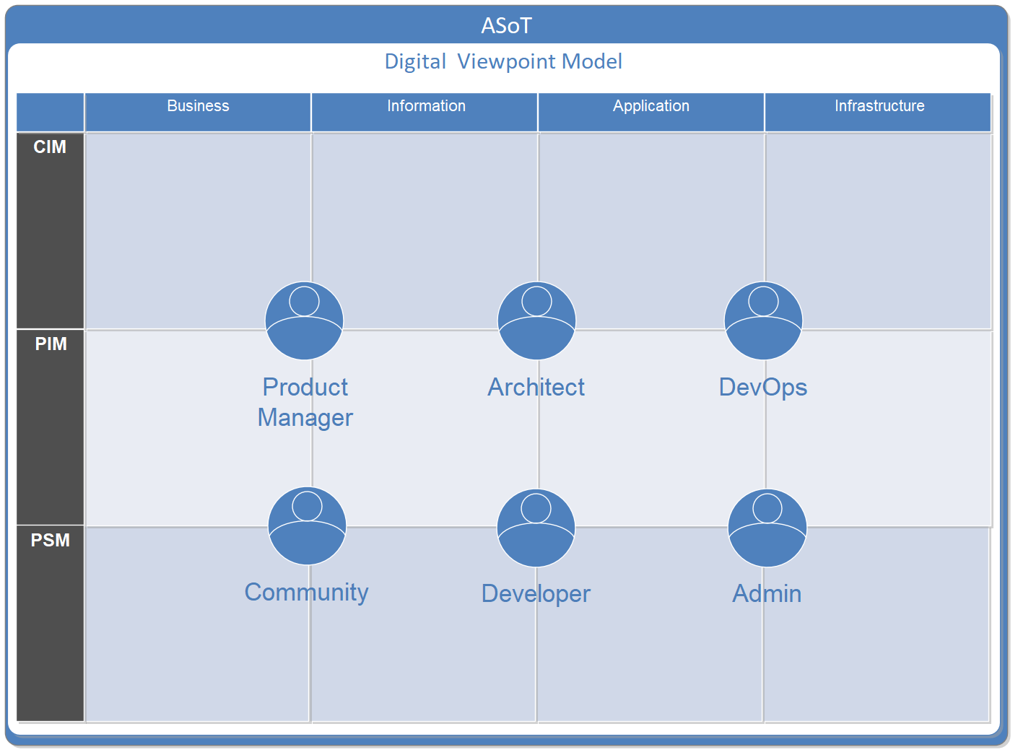
Figure 8: example of viewpoint and their stakeholders
Figure 7: Digital Viewpoint Model

DAF features 12 basic viewpoints
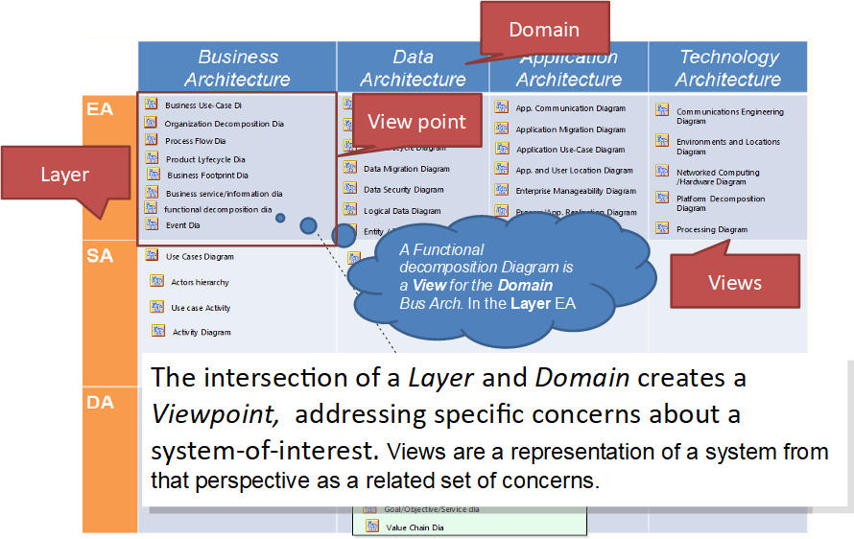
Figure 8: DAF Viewpoints
Views are representations of a system from that perspective as a related set of concerns.

DAF Concepts Organized in Viewpoints
Each of the concepts of the Metamodel belong to a specific Viewpoint. As such, it’s easier to assign responsibility to certain roles.
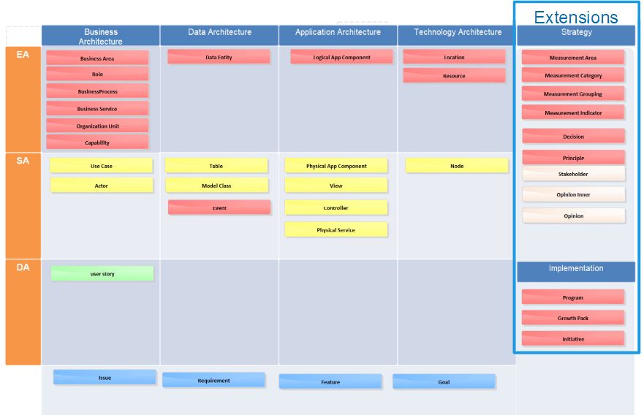
Figure 9: DAF Concepts Organized in the Viewpoints

Views and work products
DAF supports the SPEM concept of Deliverable.
A Deliverable is created when a role performs an activity within a process that produces one or more views. Each view is built from the DAF entities stored in the repository catalog. Multiple views together form a complete deliverable.

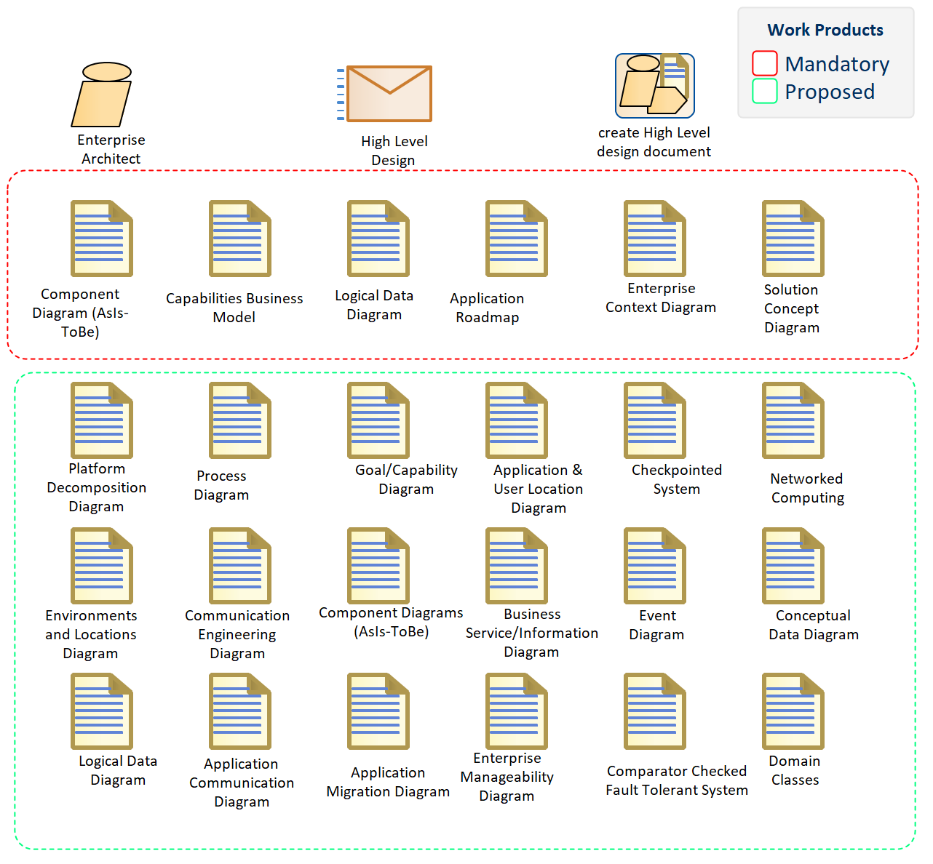
Figure 10: SPEM View with the Work Products That Compose the High-Level Design Deliverable
In the example above, the Enterprise Architect performs the activity Create High-Level Design Document. The result is the High-Level Design deliverable. This includes mandatory work products, such as the Component Diagram (As-Is/To-Be) and the Capability Business Model. Depending on the scope, it may also include optional work products, like the Platform Decomposition Diagram or the Process Diagram.
By its nature, a deliverable is like a 2D photo: it presents a static view that does not necessarily expose all implications or dependencies. However, the underlying model contains the full traceability, which can be retrieved to perform impact analysis and uncover relationships not immediately visible in the deliverable itself.

Relationships
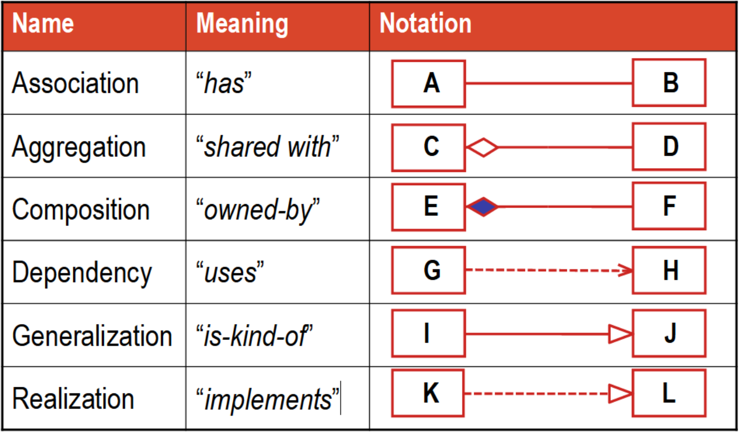
Figure 11: Basic UML relationships
DAF relationships are extending fundamental UML relationships:
- Association: A relationship that models a bi-directional semantic connection among instances
- Aggregation: A special kind of association that models a “whole-part” as shared relationship
- Composition: non-shareable, non-transferable ownership
- Dependency: A relationship that signifies that a single or a set of model elements requires other model elements
- Generalization: A taxonomic relationship between a more general element and a more specific element
- Realization: A specialized abstraction relationship between two sets of model elements, one representing a specification (the supplier) and the other represents an implementation of the latter (the client)

In the DAF metamodel, inheritance uses Generalizations, transitions of abstraction layers are represented with stereotyped Realization, strong connections between elements of the same abstraction level with stereotyped Associations, weak relationships with Dependencies; strong hierarchical relationships with Compositions, weak ones with Aggregations.

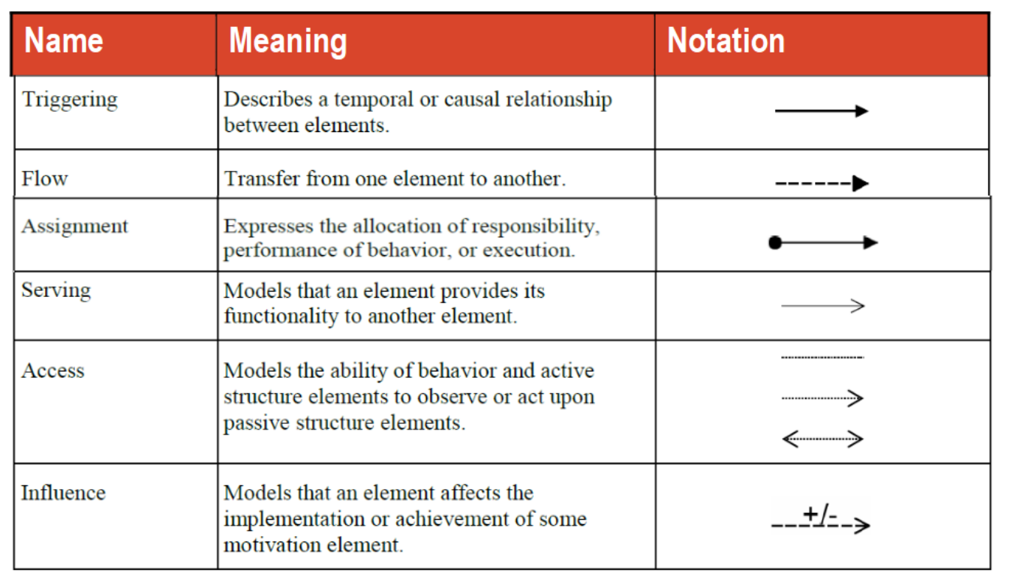

Relationship Strategy
Figure 12: Additional ArchiMate relationships
The DAF Metamodel is designed to support the concept of encapsulation.
Encapsulation is a key concept in modeling that refers to the practice of enclosing concept and behaviors within a single entity, so as to protect its internal state from external interference. This helps to maintain the integrity of the model by controlling the flow of information and avoiding circular references. In object-oriented modeling, encapsulation allows objects to interact with one another without being dependent on their implementation, creating a level of abstraction that makes the system more flexible and maintainable.

Circular references in modeling refer to the situation where two or more models or elements within a model refer to each other in a circular manner. This creates a situation where one element depends on another, which in turn depends on the first, leading to a never-ending chain of inter-dependencies. Circular references are often considered problematic in modeling because they can lead to ambiguities and inconsistencies in the models, making it difficult to analyze and understand the relationships between elements. They can also cause problems with automated analysis and interpretation tools that rely on the models.
Instead of circular references, derived relationships are used.
A derived relationship refers to a relationship that is obtained or computed from other relationships or information in the model. It is not directly specified in the model but is instead derived from existing elements and their properties and relationships. Derived relationships are often used to simplify a model and make it more manageable by abstracting complex relationships and showing only the essential relationships between elements. These relationships may also be used to generate additional information about the system being modeled or to support certain modeling activities such as impact analysis, traceability, and consistency checks.

Detailed Documentation
The following is the complete documentation of the DAF metamodel

DAF Concepts Overview
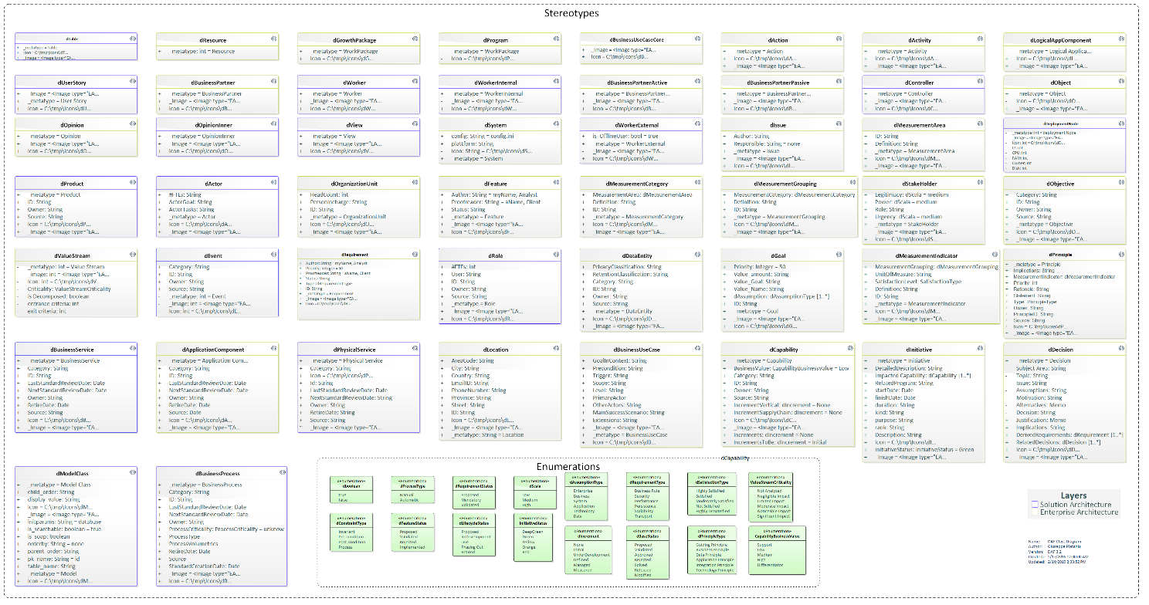
Figure 13: DAF Concepts and Properties
DAF version 6.3 supports ~71 concepts (implemented as UML Stereotypes), each of those has several properties (expressed as UML Tagged Values)
Domain | Technical  Name | Human Name | Documentation
Application | dTest | Test | Represents a mechanism for verifying or validating the functionality, behavior, or compliance of an application component. Tests can include automated or manual procedures designed to ensure alignment with requirements, detect defects, and confirm expected outcomes.
Application | dModelClass | Model Class | Represent a class of the domain model, that can be converted into a Persistent domain class, must inherit from Node. It is the application's dynamic data structure
Application | dLogicalAppComponent | Logical App Component | Encapsulates logical software components independent of implementation or technology.
Application | dApplicationFunction | Application Function | Encapsulates functions supported by applications.
Application | dController | Controller | Encapsulates application behavior and flow logic.
Application | dValue | Value | An attribute of a Node value type used in DAF. These values are persistent
Application | dApplicationComponent | Application Component | An application component is a self-contained unit. As such, it is independently deployable, re-usable, and replaceable. An application component performs one or more application functions. It encapsulates its behavior and data, exposes services, and makes them available through interfaces. Cooperating application components are connected via application collaborations.  An application component may be assigned to one or more application functions. An application component has one or more application interfaces, which expose its functionality. Application interfaces of other application components may serve an application component. The name of an application component should preferably be a noun.
Application | dView | View | A View used in DAF. Controller, Views and Associations define the application flow
Application | dPhysicalService | Physical Service | a technical implementation of a service that runs on physical or virtual infrastructure, providing specific functionalities, usually in the form of software applications, middleware, databases, or platforms. It is concerned with the deployment, operation, and management of the technology stack, ensuring that the service is available, performant, and reliable. Examples include web servers, APIs, databases, and network services.
Application | dValueRef | Value Ref. | A Node value type used in DAF that reference another Node Value, similar to a foreign Key. These values are persistent
Business | dRole | Role | The usual or expected function of an actor, or the part somebody or something plays in a particular action or event. An actor may have a number of roles.
Business | dActivity | Activity | Represents business or system activities. A function or work carried out by the business user.
Business | dActor | Actor | Represents an entity (such as a person, system, or organization) that interacts with the system to achieve a specific goal. An actor typically performs actions within business Use cases and can be internal (e.g., employees) or external (e.g., customers or partner organizations), active and passive.
Business | dBusinessUseCase | Business Use Case | Encapsulates business processes producing value for an enterprise.
Business | dBusinessService | Business Service | A system configuration. Settings are modeled as attributes with default values
Business | dAction | Action | A specialized activity.
Business | dEvent | Event | A behavioral situation that causes a change in the state of an element (typically a Process)
Business | dBusinessProcess | Business Process | A sequence of activities that produce a specific service or product supporting a particular business capability.
Data | dTable | Table | Represents physical tables in a database schema.
Data | dObject | Object | an Object is an instance of a class in a particular moment in runtime that can have its own state and data values.
Implementation | dDecision | Decision | Represents decisions and their impact on architecture or processes.
Implementation | dUserStory | User Story | Captures user-centric requirements expressed as stories.
Implementation | dInitiative | Initiative | An activity carried out by a Business Unit or organization to achieve a particular goal or improve the Maturity of a certain capability.
Implementation | dGrowthPackage | Growth Package | A set of actions identified to achieve one or more objectives for the business. A work package can be a part of an Initiative, a complete project, or a part of a Program. A Growth pack is a collection of Initiatives architected for consistency and aimed to be executed in the same period.
Implementation | dProgram | Program | A group of Growth Packages that achieve a complex outcome for the organization
Requirement | dRisk | Risk | Identifies and assesses potential issue impacting other elements. A risk is a potential future Issue.
Requirement | dFeature | Feature | A Feature is a fact that set his related Requirement to be true
Requirement | dIssue | Issue | A concrete problem that is affecting a business. Also, a fact that sets a Requirement to be false. (see also Risk)
Requirement | dRequirement | Requirement | A business guideline about the Enterprise or the project. A requirement is formulated in a SMART fashion and uses Moscow verbs (Must Have, Should Have, Could Have, and Would Like to Have.). Requirements can be decomposed.  - Must Have: These are the requirements that are considered essential for the success of the project and must be met for the system to function. They are often referred to as "hard" or "mandatory" requirements and are typically expressed in Boolean format as "true" or "1".  - Should Have: These are the requirements that are considered important, but not essential. They are typically expressed in Boolean format as "maybe" or "0/1" and are often used to prioritize the development of the system.  - Could Have: These are the requirements that are considered desirable but not essential. They are typically expressed in Boolean format as "false" or "0". They are used to identify potential enhancements to the system that can be added at a later date.  - Would Like to Have: These are the requirements that are considered less important and are often used to identify potential future enhancements to the system.  In addition, the requirement should be SMART, which stands for Specific, Measurable, Achievable, Relevant, and Time-bound. SMART requirements are clear, concise, and easy to understand, and they provide a clear way to measure the success of the project.
Requirement | dGoal | Goal | A measurable scope that the organization wants to achieve. Can be hierarchically decomposed.
Strategy | dMeasurementIndicator | Measurement Indicator | The specific measure captured for an organization or Business Unit which can be measured and quantifiable. A measurement is a Key Performance indicator
Strategy | dMeasurementArea | Measurement Area | Represents areas of organizational or business performance measurement. The organization or Business units’ performance objective is captured as measurement area.
Strategy | dStakeholder | Stakeholder | Represents any party or force influencing the domain of interest. Any person or force that has an interest in the considered domain. This is typically indicated by name, can be connected with a Role in the organization. A stakeholder has open and Inner opinions that are relevant for the subject matter.
Strategy | dCapability | Capability | Represents an organizational capability to achieve business outcomes. Can be currently available in an Organization Unit (or) A business-focused outcome that is delivered by the completion of one or more work packages (by increasing the capability Maturity).
Strategy | dProduct | Product | Encapsulates outputs produced by business processes.
Strategy | dPrinciple | Principle | Defines qualitative statements guiding architecture intent.
Strategy | dOrganizationUnit | Org Unit | Defines organizational units responsible for roles, can be decomposed
Strategy | dMeasurementCategory | Measurement Category | Categorizes measurements within a measurement area.
Strategy | dOpinionInner | Inner Opinion | Captures implicit stakeholder opinions related to a topic.  A Stakeholder’s opinion that is relevant for the topic but is not formulated explicitly.
Strategy | dSkill | Skill | an ability that some role possesses with various degree
Strategy | dOpinion | Opinion | A view or judgment formed about a Topic. That is formulated in an explicit fashion. Captures explicit stakeholder judgments on a topic.
Strategy | dResource | Resource | a type of Asset supporting a Business Capability
Strategy | dObjective | Objective | A time-bounded milestone for an organization used to demonstrate progress towards a goal. The Objective is a non material achievement, other than a Goal, the objective has no specific value to be measured
Strategy | dValueStream | Value Stream | A representation of an end-to end collection of value-adding Business Processes that create an overall result for a customer, stakeholder or end user
Strategy | dLocation | Location | A place where business activity takes place and can be hierarchically decomposed.
Strategy | dMeasurementGrouping | Measurement Grouping | a group of Measurement Indicator that can be aggregated into Categories
Technology | dJSON_Schema | JSON Schema | The Schema Object allows the definition of input and output data types. These types can be objects, but also primitives and arrays. This object is based on the JSON Schema Specification Draft 4 and uses a predefined subset of it. On top of this subset, there are extensions provided by this specification to allow for more complete documentation
Technology | dDeploymentModel | Deployment Model | The root class for the description of deployments to roll out an application, service, or container to a set of resources. similar to ArchiMate's Technology Layer deployment views.
Technology | dNetwork | Network | The main communication medium between services and deployments, mapped to ArchiMate Communication Networks, facilitating inter-service communication.
Technology | dJSON_SchemaSubSet | JSON Schema Sub Set | Represents subsets of JSON schema structures.
Technology | dAPIResponse | API Response | Represents responses returned by API operations.
Technology | dJSON_Element | JSON Element | Represents elements or nodes in JSON schemas.
Technology | dJSON_Type | JSON Type | Represents data type definitions for structured information.
Technology | dCluster | Cluster | Represents a set of nodes working in the same Region, similar to ArchiMate’s Node concept within a server infrastructure.
Technology | dDeploymentNode | Node | Represents a physical machine or virtual server that hosts services, applications, or containers, similar to ArchiMate’s Node concept in the Technology Layer.
Technology | dJSON_Datatype | JSON Data Type | Represents a data type used within JSON structures, defining the format and constraints of data elements in a schema. JSON Data Types include standard types such as string, number, object, array, boolean, and null, ensuring consistency and validation in data exchange between systems.
Technology | dVolume | Volume | Refers to the storage assigned to containers, ensuring persistence, aligning with the Data Object in ArchiMate’s Application Layer.
Technology | dAPI | Open API | OpenAPI Specification is an open-source format and initiative for designing and creating machine-readable interface files that are utilized in producing, describing, consuming, and visualizing RESTful APIs and web services.
Technology | dContainer | Container | Encapsulates application components and services, mirroring ArchiMate's concept of a Node, where an application runs.
Technology | dAPIParameter | API Parameter | Defines parameters in API operations.
Technology | dAPIOperation | API Operation | Defines operations exposed by an API for interaction with external systems. Also called endpoints.
Technology | dZone | Zone | Defines macro divisions containing regions mapped to ArchiMate’s Infrastructure Service.
Technology | dJSON_Attribute | JSON Attribute | Defines attributes in JSON data structures.
Technology | dIPRange | IP Range | Defines a range of IP addresses (CIDR) used within a network. This aligns with ArchiMate's concept of Infrastructure Service, providing connectivity.
Technology | dSecurityGroup | Security Group | Controls and manages access and permissions between services, in line with TOGAF's Security Architecture for protecting digital assets.
Technology | dOnPremise | On Premise Node | an organization of Business interests
Technology | dDataEntity | Data Entity | An encapsulation of data that is recognized by a business domain expert as a thing. Logical data entities can be tied to applications, repositories, and services and may be structured according to implementation considerations.
Technology | dSystem | System Configuration | A system configuration. Settings are modeled as attributes with default values; each attribute of the System Config becomes a line in the configuration file.  e.g. SystemConfig.path = c:/users/app
Technology | dSubNetwork | Sub Network | A subset of a network, used to organize and isolate portions of the network. Equivalent to an ArchiMate Node, responsible for networking resources.
Technology | dPublicCluster | Public Cluster | A public cloud-based cluster, following the ArchiMate concept of Infrastructure Service provided by external cloud providers (Google, AWS, etc.).
Technology | dRegion | Region | A geographic area containing clusters and zones, aligned with ArchiMate's Location concept for representing deployment geography.

DAF Relationship Types
Technical name | Human Name | Destination | Source
dAccord | According Opinion | is in accord with other Opinion | is in accord with original Opinion
dActionKey | Action Key | target Controller | Source Controller
dActivityContainsAction | Activity contains Action | is contained in Activity | contains Action
dActorParticipatesInBizUseCase | Actor Participates In Use Case | Partecipates in Use Case | is executed by Actor
dApplicationAgregatesFunction | aggregates Function | aggregates Function | part of Application
dApplicationComponentRealizesogicalComponent | Realizes Component | Realizes Logical component | is Realized by Component
dApplicationconfiguredbySystemConfiguration | Application configured by System Configuration | has configuration | configures Application
dApplicationConnectedWithApplication | Connects Application | connected From Application | Connected to Application
dApplicationExposesService | Application Exposes Ph. Service | is exposed by Application | Exposes Phy Service
dApplicationHasOwner | Application has Owner | owns Application | has Owner
dApplicationIRunsInNode | Application is run By Node | Runs Application | is run By Node
dApplicationRisk | Application Risk | is related to Application | has Risk
dAreaAggregatesCategories | Area aggregates Categories | aggregates categories | has Measurement Area
dBizServIsDescribedByUseCase | Biz Serv Is Described By Use Case | Has service | described by Use Case
dBizServUsesDataEntity | Service Uses Data | uses Data | is used by service
dBusinessAreadHasCapability | has Capability | has Capability | is organized in Biz Area
dCapabilityisMeasuredByKPI | is Measured By KPI | is Measured By Indicator | is measuring Capability
dCategoryaggregatesGroups | aggregates Groups | aggregates Groups | has Category
dContainerAggregatesVolume | Container Aggregates Volume | Aggregates Volume | is Aggregated in Container
dControllerControllsModel | Controlls Model | Controlls Model | is controlled by Controller
dControllerGovernsView | Governs View | Governs view | is Governed by Controller
dControllerImplementsFunction | controller Implements function | Implements function | has Controller
dDataEntityInformsCapability | informs Capability | is informed by Data Entity | Informs Capability
dDecisionRefersToPrinciple | Decision refers To Principle | refers To Principle | is referenced by Decision
dDiscord | Discording opinion | is in discord with other Opinion | is in discord with Original Opinion
dEntityAssociatesEntity | Entity Associates Entity | Is connected to Source Entity | Is connected to Target Entity
dEntityisFunctionallyImplementedByTable | Entity is Functionally Implemented By Table | Implements Entity | is Functionally Implemented By Table
dEventTriggersProcess | Event Triggers Process | triggers Process | is triggered by Event
dFeatureIsRealizedByUseCase | Feature is realized by Use Case | realizes Feature | is realized by Use Case
dGoalAggregatesGoal | Goal Aggregates Goal | parent Goal | Child Goal
dGoalhasObjective | Goal has Milestone | Has Objective | is related to Goal
dGoalisOperationalizedByCapability | goal is Operationalized By Capability | support Goal | is Operationalized By Capability
dGroupAggregatesKPI | Group aggregates KPI | aggregates KPI | part of a Grouping
dInitiativeIncreasesMaturityOf | Initiative Increases Maturity Of Capability | Increases Maturity Of Capability | is matured by Initiative
dInitiativeisMakingUseOfDecision | Initiative is Making Use Of Decision | is used in Initiative | Makes Use Of Decision
dIssueStopsRealizationOfRequirement | Issue Stops Realization Of Req | stop Requirement | is stopped by Issue
dLocationHostsNode | Location Hosts Node | Hosts Node | Is hosted in Location
dLogAppCompExposesBizService | exposes Biz Service | application runs service | service run by application
dLogicalApplicationComponentSupportsCapability | App Supports Capability | supported by Application | supports Capability
dModelClassRealizesEntity | Model Class Realizes Entity | Realizes Entity | is realized by Class
dNetworkContainsNode | Contains Node | Contains Node | is contained in a Network
dNetworkHasSecurityGroup | Network Has Security Group | Has Security Group | is associated to Network
dObjectInstanceofController | Instance of Controller | Has an Instance | Istance of Controller
dObjectInstanceofModel | Instance of Model | Has an Instance | Istance of Model
dObjectInstanceofView | Instance of View | Has an Instance | Istance of View
dOrgUnitHasStakeholders | Org Unit has Stakeholders | has Stakeholder | is concerned with Organization
dPackageIsDeliveredByInitiative | Package is delivered by Initiative | is delivered by Initiative | is part of a Package
dPhysicalServiceImplementsBusinessService | Physical Serv. Implements Biz Serv. | Implement Biz Service | is Implemented by physical service
dProcessEnsureCorrectOperationOfCapability | Ensure the correct Operation of | is operated by Process | Ensure the correct Operation of Capability
dProcessFlowsToProcess | Process Flows to Process | Sequence Flow To | Sequence Flow From
dProcessOrchestratesService | Process Orchestrates Service | Has Service | part of Process
dProductIncludesProcess | Product Includes Process | Includes Process | Is part of Product
dProgramIsOrganizedInPackages | Program is organized In Packages | is organized In Packages | part of a Program
dRelatedService | Child Process | Target Service | Source Service
dRequirementContainsRequirement | Requirement Contains Req | is contained by Requirement | Contains Requirement
dRequirementIsRelatedToGoal | req related to Goal | specifies Goal | is specified by Requirement
dRequirementIsSatisfiedByFeature | is Satisfied By | realizes Requirement | is realized by Feature
dResourceimpactedByRisk | Resource impacted by Risk | impact Resouce | is impacted by Risk
dResourceSupportsCapability | Resource supports Capability | Supports Capability | is supported By Resource
dRiskIRelatedToRisk | Risk is related to Risk | target Risk | Source Risk
dRiskRealizedByIssue | realized by Issue | is realizing Risk | is realized by Issue
dRoleConsumesService | Role Consumes Service | Consumes Service | is consumed by Role
dRoleExecutesCapability | role Executes Capability | is executed by Role | executes Capability
dRoleHasSkill | Role has skill | has SKill | known by Role
dRoleisAssociatedToOrganization | Role is Associated To Organization | works in Organization | has Role
dRoleIsPerformedByActor | Role is Performed By Actor | has Role | is executed by Actor
dStakeholderHasInnerOpinion | Stakeholde Has Inner Opinion | Has Inner Opinion | is thinked by Stakeholder
dStakeholderHasOpinion | Stakeholder Has Opinion | Has Opinion | is expressed by Stakeholder
dTableProvidesPersistenceForModelClass | Table Provides Persistence to Model | is Saved in a Table | Provides Persistence For Model
dTest_ApplicationComponent | Test validates Component | Test validates Component | is validated by test
dUseCaseContainsActivities | Use Case Contains Activities | has Activitiy | part of UseCase
dUseCaseHasStory | Use Case Has Story | Is associated to Use Case | Can be told as User Story
dUseCaseisImplementedByController | Use Case is Implemented B y Controller | implements Use Case | Is implemented by Controller
dValueStreamIncludesProcesses | Value Stream Includes Processes | Includes Process | is part of Value Stream
TMF_isComposedByProcess | is Composed By Process | is Composed By Process | is Composed within Process
TMF_ProcessProducesEntity | Produces Entity | Process produces Entity | Entity is produced by process
TMF_ProcessUsesEntity | Process Uses Entity | Uses Entity | is used by Process
TMF_RelatedUseCase | Related Use Case | target related Use Case | related Use Case
TMF_ThemeComposesUserStory | Composes User-Story | Composes User-Story | is composed In Theme
TMF_UseCaseAssociatedWithTestCase | Associated With Test Case | Associated With Test Case | Associated With Use-Case
TMF_Use-CaseDependOnTool | Depends On Tool | Depends On Tool | Is depended of Use-Case
TMF_Use-CaseDependsOnPolicy | Depends On Policy | Depends On Policy | is dependent of Use-Case
TMF_Use-CaseDependsOnUser-Story | Depends On User-Story | Depends On Use-Case | Depends On User-Story
TMF_UseCaseRelatedProcess | Related Process | related to Process | related to Use Case
TMF_ValueStreamAggregatesValueStage | Aggregates Value Stage | Aggregates Value Stage | is aggregated by Value Stream
TMF_VerticalAggregatesProcess | Vertical Aggregates Process | Aggregates Process | Is aggregated in Verticals
TMF_VerticalComposedVertical | Vertical Composes Vertical | Child Vertical | Parent Vertical

DAF Relationships Quick link
Source→ Relationship Name → target | Source→ Relationship Name → target
dActivity -> dActivityContainsAction -> dAction | is contained in Activity
contains Action | dActor -> dActorParticipatesInBizUseCase -> dBusinessUseCase
Partecipates in Use Case | is executed by Actor
dActor -> dRoleIsPerformedByActor -> dRole | has Role
is executed by Actor | dAPI -> dAPIAggregatesSchema -> dJSON_Schema
Aggregates Schema | is aggregates in API
dAPI -> -> dPhysicalService | dApplicationComponent -> dApplicationComponentRealizesogicalComponent -> dLogicalAppComponent
Realizes Logical component | is Realized by Component
dApplicationComponent -> dApplicationconfiguredbySystemConfiguration -> dSystem | has configuration
configures Application | dApplicationComponent -> dApplicationExposesService -> dPhysicalService
is exposed by Application | Exposes Phy Service
dApplicationComponent -> dApplicationHasOwner -> dStakeholder | owns Application
has Owner | dApplicationComponent -> dApplicationConnectedWithApplication -> dApplicationComponent
connected From Application | Connected to Application
dApplicationComponent -> dApplicationAgregatesFunction -> dApplicationFunction | aggregates Function
part of Application | dApplicationComponent -> dApplicationComponentHasContainer -> dContainer
Has Container | contains Application
dBusinessProcess -> dProcessOrchestratesService -> dBusinessService | Has Service
part of Process | dBusinessProcess -> dProcessFlowsToProcess -> dBusinessProcess
Sequence Flow To | Sequence Flow From
dBusinessService -> dBizServUsesDataEntity -> dDataEntity | uses Data
is used by service | dBusinessService -> dRelatedService -> dBusinessService
Target Service | Source Service
dBusinessUseCase -> dBizServIsDescribedByUseCase -> dBusinessService | Has service
described by Use Case | dBusinessUseCase -> dUseCaseContainsActivities -> dActivity
has Activitiy | part of UseCase
dBusinessUseCase -> dFeatureIsRealizedByUseCase -> dFeature | realizes Feature
is realized by Use Case | dCapability -> dProcessEnsureCorrectOperationOfCapability -> dBusinessProcess
is operated by Process | Ensure the correct Operation of Capability
dCapability -> dCapabilityisMeasuredByKPI -> dMeasurementIndicator | is Measured By Indicator
is measuring Capability | dCapability -> dRoleExecutesCapability -> dRole
is executed by Role | executes Capability
dCapability -> dGoalisOperationalizedByCapability -> dGoal | support Goal
is Operationalized By Capability | dCapability -> dLogicalApplicationComponentSupportsCapability -> dLogicalAppComponent
supported by Application | supports Capability
dCapability -> dDataEntityInformsCapability -> dDataEntity | is informed by Data Entity
Informs Capability | dCluster -> dClusterContainsDeploymentNode -> dDeploymentNode
Contains DeploymentNode | is Contained in Cluster
dContainer -> dContainerAggregatesVolume -> dVolume | Aggregates Volume
is Aggregated in Container | dController -> dControllerImplementsFunction -> dApplicationFunction
Implements function | has Controller
dController -> dControllerGovernsView -> dView | Governs view
is Governed by Controller | dController -> dControllerControllsModel -> dModelClass
Controls Model | is controlled by Controller
dController -> dUseCaseisImplementedByController -> dBusinessUseCase | implements Use Case
Is implemented by Controller | dController -> dActionKey -> dController
target Controller | Source Controller
dDataEntity -> dEntityAssociatesEntity -> dDataEntity | Is connected to Source Entity
Is connected to Target Entity | dDecision -> dInitiativeisMakingUseOfDecision -> dInitiative
is used in Initiative | Makes Use Of Decision
dDecision -> dDecisionRefersToPrinciple -> dPrinciple | refers To Principle
is referenced by Decision | dDeploymentModel -> dDeploymentModelAggregatesCluster -> dCluster
Aggregates Cluster | is Aggregated in Deployment Model
dDeploymentNode -> dApplicationIRunsInNode -> dApplicationComponent | Runs Application
is run By Node | dEvent -> dEventTriggersProcess -> dBusinessProcess
triggers Process | is triggered by Event
dFeature -> dRequirementIsSatisfiedByFeature -> dRequirement | realizes Requirement
is realized by Feature | dGoal -> dGoalhasObjective -> dObjective
Has Objective | is related to Goal
dGoal -> dGoalAggregatesGoal -> dGoal | parent Goal
Child Goal | dGrowthPackage -> dPackageIsDeliveredByInitiative -> dInitiative
is delivered by Initiative | is part of a Package
dInitiative -> dInitiativeIncreasesMaturityOf -> dCapability | Increases Maturity Of Capability
is matured by Initiative | dIssue -> dIssueStopsRealizationOfRequirement -> dRequirement
stop Requirement | is stopped by Issue
dIssue -> dRiskRealizedByIssue -> dRisk | is realizing Risk
is realized by Issue | dJSON_Element -> dJSONElement_associates_JSONElement -> dJSON_Element
target JsonElement | Source JsonElement
dJSON_Schema -> dPolymorphicCollection -> dJSON_Schema | @baseType
@Type | dJSON_Schema -> dJSON_SchemaSubSetGeneralizes_JSON_Schema -> dJSON_SchemaSubSet
Parent Schema | Child Schema
dJSON_Schema -> dSchema_Associates_Schema -> dJSON_Schema | Target Schema
Source Schema | dJSON_Schema -> dSchemaGeneralizesSchema -> dJSON_Schema
Child Schema | Parent Schema
dJSON_Schema -> dSchemaAssociatesElement -> dJSON_Element | Associates Element
Associates Schema | dJSON_Schema -> dJSONSchemaRealizesModel -> dModelClass
realizes Model Class | is realized by Schema
dLocation -> dLocationHostsNode -> dDeploymentNode | Hosts Node
Is hosted in Location | dLogicalAppComponent -> dLogAppCompExposesBizService -> dBusinessService
application runs service | service run by application
dMeasurementArea -> dAreaAggregatesCategories -> dMeasurementCategory | aggregates categories
has Measurement Area | dMeasurementCategory -> dCategoryaggregatesGroups -> dMeasurementGrouping
aggregates Groups | has Category
dMeasurementGrouping -> dGroupAggregatesKPI -> dMeasurementIndicator | aggregates KPI
part of a Grouping | dModelClass -> dModelClassRealizesEntity -> dDataEntity
Realizes Entity | is realized by Class
dModelClass -> dTableProvidesPersistenceForModelClass -> dTable | is Saved in a Table
Provides Persistence For Model | dNetwork -> dNetworkContainsNode -> dDeploymentNode
Contains Node | is contained in a Network
dNetwork -> dNetworkHasSecurityGroup -> dSecurityGroup | Has Security Group
is associated to Network | dNetwork -> dNetworkAggregatesSubNetwork -> dSubNetwork
Aggregates Sub-Network | is Aggregated in Network
dObject -> dObjectInstanceofModel -> dModelClass | Has an Instance
Istance of Model | dObject -> dObjectInstanceofController -> dController
Has an Instance | Istance of Controller
dObject -> dObjectInstanceofView -> dView | Has an Instance
Istance of View | dOpinion -> dDiscord -> dOpinion
is in discord with other Opinion | is in discord with Original Opinion
dOpinion -> dAccord -> dOpinion | is in accord with other Opinion
is in accord with original Opinion | dOrganizationUnit -> dOrgUnitHasStakeholders -> dStakeholder
has Stakeholder | is concerned with Organization
dPhysicalService -> dPhysicalServiceImplementsBusinessService -> dBusinessService | Implement Biz Service
is Implemented by physical service | dProduct -> dProductIncludesProcess -> dBusinessProcess
Includes Process | Is part of Product
dProgram -> dProgramIsOrganizedInPackages -> dGrowthPackage | is organized In Packages
part of a Program | dRegion -> dRegionAggregatesCluster -> dCluster
Aggregates Cluster | is Aggregated in Region
dRequirement -> dRequirementIsRelatedToGoal -> dGoal | specifies Goal
is specified by Requirement | dRequirement -> dRequirementContainsRequirement -> dRequirement
is contained by Requirement | Contains Requirement
dResource -> dResourceSupportsCapability -> dCapability | Supports Capability
is supported By Resource | dRisk -> dRiskIRelatedToRisk -> dRisk
target Risk | Source Risk
dRisk -> dResourceimpactedByRisk -> dResource | impact Resouce
is impacted by Risk | dRisk -> dApplicationRisk -> dApplicationComponent
is related to Application | has Risk
dRole -> dRoleisAssociatedToOrganization -> dOrganizationUnit | works in Organization
has Role | dRole -> dRoleConsumesService -> dBusinessService
Consumes Service | is consumed by Role
dRole -> dRoleHasSkill -> dSkill | has SKill
known by Role | dSecurityGroup -> dSecurityGroupHasPhysicalService -> dPhysicalService
has Physical Service | Asociated to Sec. group
dStakeholder -> dStakeholderHasInnerOpinion -> dOpinionInner | Has Inner Opinion
is thinked by Stakeholder | dStakeholder -> dStakeholderHasOpinion -> dOpinion
Has Opinion | is expressed by Stakeholder
dSubNetwork -> dSubNetworkAggregatesIPRange -> dIPRange | Aggregates IP Range
is Aggregated in sub Net. | dTable -> dEntityisFunctionallyImplementedByTable -> dDataEntity
Implements Entity | is Functionally Implemented By Table
dTest -> dTest_ApplicationComponent -> dApplicationComponent | Test validates Component
is validated by test | dUserStory -> dUseCaseHasStory -> dBusinessUseCase
Is associated to Use Case | Can be told as User Story
dValueStream -> dValueStreamIncludesProcesses -> dBusinessProcess | Includes Process
is part of Value Stream | dValueStream -> dValueStreamEnablesCapability -> dCapability
Enables Capability | is Enabled by Value Stream
dZone -> dZoneAggregatesRegion -> dRegion | Aggregates Region
is Aggregated in Region

Visual Characteristics of some DAF stereotypes
Some DAF stereotypes have special visual characteristics. They can react to Tagged Values or other properties, e.g. diagram properties as shown below.
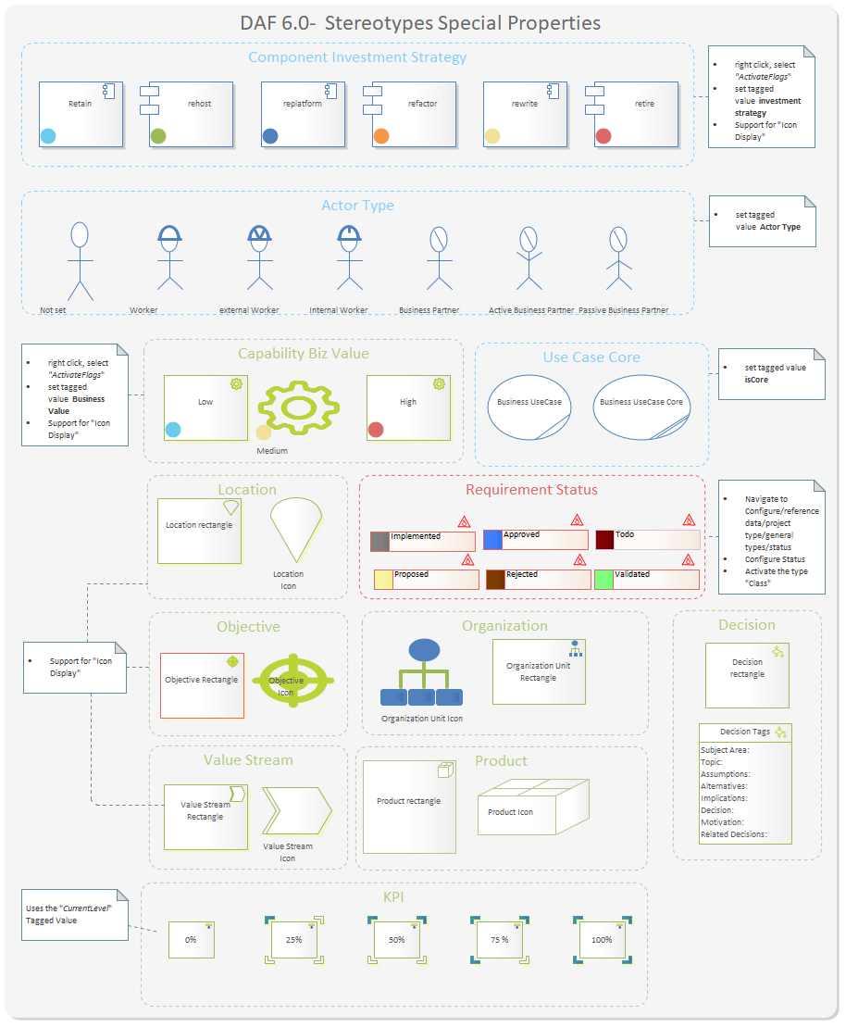
Figure 18: DAF Visual Properties

Appendices

Stereotypes and Tagged Values
Stereotype | Tagged Values | Notes
dApplicationFunction |  | a logical Function that the application is supporting
dRisk |  | the potential for an Issue
 | Likehood | the probability that this risk becomes an Issue.
 | Severity | the expected impact if the risk materializes.
 | RiskStrategy | the strategy to be adopted to manage the risk
dAction |  | A specialized activity.
dActivity |  | A function or work carried out by the business user.
dActor |  | The actor entity used for representing a User, System, a Worker or Partner.
 | #FTEs | Estimated number of FTEs that operate as this Actor.
 | ActorGoal | Objectives that this actor has, in general terms.
 | ActorType | the type of Actor
 | ActorTasks | Tasks that this actor performs, in general terms.
dApplicationComponent |  | An encapsulation of application functionality aligned to implementation structure which is modular and replaceable. It encapsulates its behavior and data, provides services, and makes them available through interfaces.
 | ID | Unique identifier for the element, useful for referring to third party systems
 | Category | User-definable categorization taxonomy for each element.
 | BizSatisfaction | How much is the business happy with the application, expressed in 1-100
 | ITSatisfaction | how is IT happy with this application, often related to technical debt.
 | BizCriticality | how is Business happy with this application, often related to business debt.
 | Cost | the cost of this application in 1000 of $
 | InvestmentStrategy
 | ApplicationType | the type of Application, e.g. if it's a COTS, Custom and so on
 | LastStandardReviewDate | Last review date for the application component.
 | NextStandardReviewDate | Next review date for the application component.
 | RetireDate | The retire date for the Application Component.
 | Owner | The owner for the application Component.
 | Port
 | Source | The original source of the element's information
dBusinessProcess |  | A business Processes represent a sequence of activities that together achieve a specified outcome, can be decomposed into Business Services. It ensures the correct operation of business capabilities.
 | Category | User-definable categorization.
 | ID | Unique identifier for the architecture entity.
 | LastStandardReviewDate | Last date that the standard was reviewed.
 | NextStandardReviewDate | Next date for the standard to be reviewed.
 | Owner | Owner of the architecture entity.
 | ProcessCriticality | Criticality of this process to business operations.
 | ProcessType | Whether this process is supported by IT or is a manual process.
 | ProcessVolumetrics | Data on frequency of process execution.
 | RetireDate | Date when the standard was/will be retired.
 | Source | Location from where the information was collected.
 | StandardCreationDate | If the product is a standard, when the standard was created.
 | _metatype
dBusinessService |  | - A repeatable activity; a discrete behavior that a building block may be requested or otherwise triggered to perform.  - . A service provided by Business that achieve a business outcome in response to a request.
 | Category | User-definable categorization for Business Service.
 | ID | Unique identifier for Business Service.
 | LastStandardReviewDate | Last date that the standard was reviewed.
 | NextStandardReviewDate | Next date for the standard to be reviewed.
 | Owner | Owner of the architecture entity.
 | RetireDate | Date when the standard was/will be retired.
 | Source | Location from where the information was collected.
dBusinessUseCase |  | A Business Use Case is part of a business process that produces an advantage to the enterprise.
 | GoalInContext | The goal should implicitly express the actor's intent or purpose of the use case, such as "Enrol Student in Seminar."
 | Precondition | A list of the conditions, if any, that must be met before a use case may be invoked. Can be a previous Use case or self the presence of the system in Scope.
 | Trigger | Event that is responsible for invocation of the use case.
 | Scope | Boundaries in which the use case is operated when invoked (E.g. CMS)
 | Level | Authorizations for operations/actions to be performed against the Chi business objects in scope. Against every object/process 4 CRUD basic operations are possible:  Create (Write)  Read (Open)  Update (Change)  Delete (Destroy)
 | OtherActors | The list of actors associated with the use case. Although this information is contained in the use case itself, it helps to increase the understandability of the use case when the diagram is unavailable.
 | MainSuccessScenario | The main path of logic an actor follows through a use case. Often referred to as the "happy path" or the "main path" because it describes how the use case works when everything works as it normally should.
 | Extensions
 | isCore
dCapability |  | A business outcome that is current available in an Organization Unit (or) A business-focused outcome that is delivered by the completion of one or more work packages.
 | BusinessValue | assess how this capability provides value to the enterprise.
 | Category | User-definable categorization for Capability
 | ID | Unique identifier for the Capability
 | Owner | Owner of the architecture entity.
 | Source | Source from where the information was collected.
 | Increments | Current (AS-IS) maturity level for the entity.  0- none  1- Initial  2- Under Development  3 - Defined  4- Managed  5 - Measured
 | IncrementsToBe | Future (To-Be) maturity level for the entity.
 | IncrementVertical | The maturity level of your vertical (the industry)
 | IncrementSupplyChain | The maturity level of your supply chain (Partners)
 | Cost | the aggregated cost of this Capability. Includes all the aggregated cost's elements
 | Criticality | What is the criticality of this capability, what would be the cost of failure
 | Risk | How much Risk connected to this business Capability. 1 low risk, 100 max risk.
 | CapabilityLevel | the level of this category in the hierarchy
dController |  | The Controller defines application behavior and the Business Logic involving more than one ModelClass. It dispatches requests and selects views for presentation. It interprets user inputs and maps them into actions.  Controller, with Views and Associations define the application flow. A controller represents the Business logic where a certain flow is physically implemented.  In a Service Oriented Architecture (SOA) a Controller can be exposed by a Physical Service.
dDataEntity |  | An encapsulation of data that is recognized by a business domain expert as a thing. Logical data entities can be tied to applications, repositories, and services and may be structured according to implementation considerations.
 | PrivacyClassification | Level of restriction placed on access to the data.
 | RetentionClassification | Level of retention to be placed on the data.
 | Category | User-definable categorization.
 | ID | Unique identifier for the Data Entity.
 | Owner | Owner of the Data Entity.
 | Source | Location from where the information was collected.
dDecision |  | A decision-making step with accompanying decision logic used to determine execution approach for a process or to ensure that a process complies with governance criteria.  documents important decisions about any aspect of the initiative including the structure of the system, the provision and allocation of function, the contextual fitness of the system and adherence to standards.
 | Subject Area | Area of Concern
 | Topic | Topic of Interest
 | Assumptions | What is believed to be true about the context of the problem, constraints on the solution.
 | Motivation | Why this decision is important.
 | Alternatives | A list of alternatives and explanations
 | Decision | The decision taken, possibly with references to related work products
 | Justification | Why the decision was made and a list of compliance to Architecture Principles and explanations of deviations from compliance.
 | Implications | What impact the decision will have
 | RelatedDecisions | A list of related decisions
dDeploymentNode |  | a deployment node represents a physical or a virtual machine.
 | IP | The Ip of this machine
 | PublicIP
 | CPU | the number and type of CPU
 | RAM | the Memory dimension
 | Owner | The owner / responsible for this node
 | Disk | the dimension of the disk
 | ArchitectureType | the type of CPU Architecture (e.g. AMD 64)
dFeature |  | A Feature is a fact that set his related Requirement to be true
 | Author | This feature's author's name and role in the project
 | Proofreader | This feature's revisor's name and role in the project
 | Status | This feature's status
dGoal |  | A measurable scope that the enterprise wants to achieve. Can be hierarchically decomposed.
 | ID | Unique identifier for the Goal.
 | Value_amount | The actual amount of the value this goal intends to alter
 | Value_Goal | The amount by which the value is to be altered
 | Priority | A priority in %
 | Value_Name | The name of the value this goal intends to alter
 | dAssumption | The assumptions made to achieve the goal.
dGrowthPackage |  | A set of actions identified to achieve one or more objectives for the business. A work package can be a part of an Initiative, a complete project, or a part of a Program. A Growth pack is a collection of Initiatives architected for consistency and aimed to be executed in the same period.
dInitiative |  | An activity carried out by a Business Unit or organization to achieve a particular goal or improve the maturity of a certain Capability.
 | DetailedDescription | Detailed Description of the initiative.
 | Impacted Capability | Describes the contribution this work package makes to capability delivery.
 | RelatedProgram | The Growth Package or Program associated to the Initiative.
 | startDate | The start date for the initiative.
 | finishDate | The finish date of the initiative.
 | InitiativeDuration | The expected duration of the initiative in Months/ Weeks or Years.
 | kind | To capture the type of initiative.
 | purpose | Purpose of the initiative.
 | Rank | The rank of the initiative.
 | Description | Description for the initiative.
 | initiativeStatus | a set of colors to Visually describe the health of the initiative.
dIssue |  | A concrete problem that is affecting a business. Also, a fact that sets a Requirement to be false.
 | Author | This issue's author's name and role in the project
 | Responsible | The responsible to close the present issue
dLocation |  | A place where business activity takes place. Can be hierarchically decomposed.
 | AreaCode | The area code of the Location.
 | City | The City of the Location.
 | Country | The City of the Location.
 | EmailID | The contact e-mail Id for the Location.
 | PhoneNumber | The contact phone number for the Location.
 | Province | The Province of the Location.
 | Street | The street part of the Location.
 | ID | Unique identifier for the Location
dEvent |  | An organizational state change that triggers a business process; may originate from inside or outside the organization and may be resolved inside or outside the organization.
 | Category | User-definable categorization.
 | ID | Unique identifier for the Event.
 | Owner | Owner of the Event.
 | Source | Location from where the information was collected.
dLogicalAppComponent |  | An encapsulation of application functionality that is independent of a particular implementation.
dMeasurementArea |  | The organization or business units performance objective is captured as measurement area.
 | ID | Unique identifier for the Measurement Area.
 | Definition | Definition of the Measurement Area.
dMeasurementCategory |  | The category to be measured under a measurement area.
 | MeasurementArea | The reference Measurement Area to which this category belongs to.
 | Definition | Definition of the measurement category.
 | ID | Unique identifier for the Measurement Category.
dMeasurementGrouping |  | Categorization of measurement indicators into various groups under a measurement category.
 | MeasurementCategory | Related Measurement Category to which the group belongs to.
 | Definition | Definition of the Measurement Grouping.
 | ID | Unique identifier for the Measurement Grouping.
dMeasurementIndicator |  | The specific measure captured for an organization or Business Unit which can be measured and quantifiable.
 | ID | Unique identifier for the Measurement Indicator.
 | Definition | Definition of the Measurement Indicator.
 | UnitOfMeasure | The unit of measure (if available) for the Measurement Indicator.
 | CurrentLevel | the level of the Measurement Indicator the last time that was measured.
 | SatisfactionLevel | Satisfaction level for the Measurement Indicator, desidered amount to be reached and/or Max value
 | LastStandardReviewDate | last time this KPI was reviewed
dModelClass |  | Represent a class of the domain model, that can be converted into a Persistent domain class, must inherit from Node. It is the application's dynamic data structure
 | child_order | The order of the associated children e.g. for Recipe: Image|Info|AdminInfo
 | display_value | The display value of a node e.g. for Recipe: name|AdminInfo/status|Info/status
 | initparams | The configuration section that is used on initialization of the corresponding mapper.
 | is_searchable | Indicates that this type should be included in the default search.
 | is_soap | Indicates wennever an interface (e.g SOAP or REST) should be generated for this type.
 | orderby | Definition of default sorting. Possible values: 'none' (no order), 'sortkey' (generates a 'sortkey' column, that is used for explicit sorting) or any the name of any dValue defined in the node optionally followed by [ASC|DESC] e.g. 'name ASC'
 | parent_order | The order of the associated parents.
 | pk_name | The name of the primary key column. The generator will add this if there is no appropriate attribute.
 | table_name | The name of the database table. If not given the name will be taken.
dObject |  | A dObject is a candidate for a dModelClass represented in an activity diagram. In alternative can be an instance of a Model Class
dObjective |  | A time-bounded milestone for an organization used to demonstrate progress towards a goal. The Objective is a non-material achievement, other than a Goal, the objective has no specific value to be measured
 | Category | User-definable categorization.
 | finishDate | the date in which the objective is achieved.
 | ID | Unique identifier for the Objective.
 | Owner | Owner for the Objective.
 | Source | Location from where the information was collected.
dOpinion |  | A stakeholder view or judgment formed about a Topic. That is formulated in an explicit fashion
dOpinionInner |  | A Stakeholder’s opinion that is relevant for the topic but is not formulated explicitly.
dOrganizationUnit |  | A self-contained unit of resources with line management responsibility, goals, objectives, and measures. Organizations may include external parties and business partner organizations.
 | HeadCount | Number of FTEs working within the organization.
 | ID | Unique identifier for the Organization Unit.
dPhysicalService |  | the physical realization of a Business Service
 | Id | Unique identifier for Service.
 | LastStandardReviewDate | Last date that the service was reviewed.
 | NextStandardReviewDate | Next date for the service to be reviewed.
 | Owner | Owner of the service.
 | RetireDate | Date when the service was/will be retired.
 | Source | information
dPrinciple |  | A qualitative statement of intent that should be met by the architecture. Has at least a supporting rationale and a measure of importance.
 | PrincipleID | Unique identifier for the Principle expressed as text.
 | Implications | Statement of what the principle means in practical terms.
 | PrincipleMeasurement | Identifies mechanisms that will be used to measure whether the principle has been met or not.
 | Priority | Priority of this principle relative to other principles.
 | Rationale | Statement of why the principle is required and the outcome to be reached.
 | Statement | Statement of what the principle is.
 | Type | The category of the principle.
 | Owner | Owner for the Principle
 | Source | Location from where the information was collected.
dProduct |  | Output generated by the business. The business product of the execution of a process.
 | ID | Unique identifier for the Product.
 | Owner | Owner of the Product.
 | Source | Location from where the information was collected.
 | RetireDate
 | Price
dProgram |  | a set of Initiatives that can be organized in Growth Packages
dRequirement |  | A business guideline about the Enterprise or the project. A requirement is formulated in a SMART fashion and uses Moscow verbs. Requirements can be decomposed.
 | ID | Unique identifier for the requirement.
 | Author | This requirement's author's name and role in the project
 | Status | the status of the Requirement in the workflow.
 | Priority | A priority in %. Requirements are ordered by priority.
 | Proofreader | Each requirement needs to be confirmed.  This requirement's proofreader 's name and role in the project
 | Type | The type of requirement.
dResource |  | a type of Asset supporting a business capability
 | # of items
dRole |  | The usual or expected function of an actor, or the part somebody or something plays in a particular action or event. An actor may have a number of roles.
 | #FTEs | Number of Full time Equivalent employees working in the Role.
 | User | User-definable categorization.
 | ID | Unique identifier for the Role.
 | Owner | Owner of the Role.
 | Source | Location from where the information was collected.
dStakeHolder |  | Any person or force that has an interest in the considered domain. This is typically indicated by name, can be connected with a Role in the organization. A stakeholder has open and Inner opinions that are relevant for the subject matter.
 | Legitimacy | Measure the degree of general acceptance of this stakeholder influence
 | Power | the measure of the possibilities in context that this person has to realize his objectives.
 | Urgency | the timely importance of the Stakeholder opinions
dSystem |  | A system configuration. Settings are modeled as attributes with default values
 | config | The configuration file where the settings will be placed.
 | plattform | The platform to which the configuration settings apply.
dTable |  | a physical Table in a Database
 | Database | The DB schema hosting the table
dUserStory |  | a requirement expressed from the user point of view that achieve a business value
 | TestScenario | The situation that verifies the user story is realized
 | EstimatedEffort | Effort expressed in hours
 | StoryDetails | intention of the story expressed as "As a Actor I want to do something So that I achieve Value"
dValue |  | A Node value type used in DAF. These values are persistent
 | app_data_type | The datatype used in the application e.g. DATATYPE_DONTCARE, DATATYPE_ATTRIBUTE, DATATYPE_ELEMENT or DATATYPE_IGNORE
 | db_data_type | The datatype used in the database
 | is_editable | Whether the attribute is editable or not
 | input_type | The HTML input type for the attribute e.g. select#fix:key1[val1]|key2[val2]
 | display_type | The HTML display type for the attribute e.g. image
 | restrictions_match | A regular expression that the value must match (e.g. '[0-3][0-9]\.[0-1][0-9]\.[0-9][0-9][0-9][0-9]' for date values)
 | restrictions_not_match | A regular expression that the value must NOT match
 | restrictions_description | A text describing the restrictions
 | column_name | The name of the database column. If not given the name will be taken
dValueRef |  | A Node value type used in DAF that reference another Node Value, similar to a foreign Key. These values are persistent
dValueStream |  | A representation of an end-to end collection of value-adding Business Processes that create an overall result for a customer, stakeholder or end user
 | Criticality
 | is Decomposed
 | entrance criteria
dView |  | A View used in DAF. Controller, Views and Associations. It define the application flow from the user point of view.

Model Checks
Model checks are implemented using Bellekens EA Validator. See Enterprise Architect Toolpack releases
Following checks are implemented:
Category / Type | Description of the validation rules | Rationale
All
 | An Element with the status not set | A model element must have the status set
 | Elements with the EA status Proposed not managed | Proposed status indicates that the Element is probably not managed
 | The Main DAF diagram without objects | No diagram should be empty.
 | A Diagram must not contain more than 25 elements | Ideally a diagram should not contain more than seven elements
 | A Diagram should not contain less than 2 elements | Ideally a diagram should contain at least two elements
CIM
Application Architecture | A “LogicalAppComponent” should exposes a “BusinessService” | a 'dLogicalAppComponent ' element should be connected to a 'dBusinessService' element by a ' exposes Biz Service' Connector
Business Architecture | A Goal should be connected to a Business Capability | a 'dCapability' element should be connected to a ' dGoal' element by a 'isOperationalizedBy' Connector
 | A Business Capability should be linked to a Measurement Indicator | a 'dCapability' element should be connected to a 'dMeasurementIndicator' element by a 'isMeasuredByf' Connector
 | Logical Component is not linked to a Business Capability | a 'dCapability' element should be connected to a 'dLogicalAppComponent' element by a 'Supports Capability' Connector
 | Missing link between the Business Process and a Business Capability | a 'dCapability' element should be connected to a 'dBusinessProcess' element by a 'Ensure the correct Operation' Connector
 | A Business Capability is not supported by a role | a 'dCapability' element should be connected to a Role element
 | Data Entity is not linked to a Business Capability | a 'dCapability' element should be connected to a Data Entity element
 | An Initiative should support at least one Business Capability | a 'dCapability' element can be connected to a Initiative element
 | A Business Capability is not linked to a Business Process | A Business process ensures the operation of a business capability
 | A Business Capability is not supported by at least one Logical Application | A logical application should support at least one business capability
Requirement Management | A goal should be linked to a business requirement | a 'dRequirement' element should be connected to a 'dGoal' element by a 'is related to' Connector
 | A Business Requirement should be linked to a Feature | a 'dFeature' element should be connected to a ' dRequirement' element by a 'isSatisfiedBy' Connector
Technology Architecture | The Network element should be connected to a DeploymentNode | a 'dNetwork' element should be connected to a 'dDeploymentNode' element by a 'NetworkContainsNode' Connector
 | A Location element should be connected to a deployment Node | a 'dLocation' element should be connected to a 'dDeploymentNode' element by a 'Hosts Node' Connector
PIM
Application Architecture | A Function has no documentation | A function should have some minimal documentation
 | An ApplicationComponent documentation contains long dash '–' character | dApplicationComponent documentation should not have a long dash '–' character
 | A dApplicationComponent does not have documentation | A dApplicationComponent should have some minimal documentation.
 | An dApplicationComponent name should not contain 2 spaces between words in their name | An dApplicationComponent name should not have 2 spaces between words in their name
 | An dApplicationComponent name contains leading or trailing space characters in their name | An dApplicationComponent name should not contains leading or trailing space characters in their name
 | An dApplicationComponent documentation is in HTML format (rather than plain text) | An dApplicationComponent documentation should be in plain text not in the HTML format
 | Application component has no name | Application component requires a name
 | Function has no name | A function requires a name
 | A function is not associated with an application | a function should be associated with an application
 | An ApplicationComponent is not connected to an ApplicationFunction | a 'dApplicationComponent' element should be connected to a 'dApplicationFunction' element by a 'ApplicationAgregatesFunction' Connector
 | An application Component doesn't realize a Logical Component | a 'dApplicationComponent' element should be connected to a ' dLogicalAppComponent' element by a 'Realizes' Connector
 | A system is not connected to an ApplicationComponent | a 'dApplicationComponent' element should be connected to a 'dSystem' element by a 'configured by' Connector
 | An applicationComponent does not exposes a PhysicalService | a 'dApplicationComponent' element should be connected to a 'dPhysicalService' element by a 'Exposes Service' Connector
 | A PhysicalService should Implement a BusinessService | a 'dPhysicalService' element should be connected to a 'dBusinessService' element by a 'Implements' Connector
 | A Controller should implement a Function | a 'dController' element should be connected to a 'dPhysicalService' element by a 'Implements Service' Connector
 | A Controller should Control a ModelClass | a 'dController' element should be connected to a 'dModelClass' element by a 'Controlls' Connector
 | A Controller should Implement a BusinessUseCase | a 'dController' element should be connected to a 'dBusinessUseCase' element by a 'isImplementedBy' Connector
 | A Controller should govern a View | a 'dController' element should be connected to a 'dView' element by a 'Governs' Connector
Business Architecture | A Feature is not realized by Business Use Case | a BusinessUseCase' element should be connected to a 'dFeature' element by a 'is realized by Use Case' Connector
 | A BusinessService is not described by a BusinessUseCase | a 'dBusinessUseCase' element should be connected to a 'dBusinessService' element by a 'isDescribedBy' Connector
 | Use Cases that are not in exactly one Boundary | A UseCase must appear in exactly 1 Boundary (of all Use Case-diagrams)
Technology Architecture | An ApplicationComponent is not physically hosted by a DeploymentNode | a 'dDeploymentNode' element should be connected to a 'dApplicationComponent' element by a 'isPhysicallyHostedBy' Connector
PSM
Data Architecture | One or more Class diagrams has more than 25 elements | Update the invalid Class diagrams so they have maximum 25 elements
 | There are some unreferenced Enumerations | Search and fix the Enumerations
 | ere are some unreferenced Datatypes | All the data type must be described in a class
 | Some Enumerations are without values | An Enumeration must have at least 1 value.
 | A Model class has no name (or empty name) | Model class has no name (or empty name)
 | An Association class is not related to other class(es) | Association should be related or connected to other class(es)
 | The Attribute documentation is in HTML format rather than in plain text | The Attribute documentation should be in plain text and not any other format
 | An Association documentation should not contain a long dash '–' character | Association documentation should not contain a long dash '–' character
 | An Association documentation is in HTML format (rather than plain text) | Association documentation is in HTML format (rather than plain text)
 | An Association name should not contain a long dash '–' character | Association name should not contain a long dash '–' character
 | A Datatype/Enumeration documentation contain a long dash '–' character | Datatype/Enumeration documentation should not contain a long dash '–' character
 | Datatype/Enumeration documentation should not be in the HTML format | Datatype/Enumeration documentation should be in the plain text format
 | Datatype/Enumeration does not have any documentation | Datatype/Enumeration should have some documentation
 | Some Classes containing Attributes are without datatypes | Every Attribute of a Class must have a Datatype
 | Two classes with the same name in the model | Two classes with the same name cannot be in the same model
 | A Model Class is without any relations to other entities | Entitie(s) are without any relations to other entities. This validation skips entities which are marked as <<baseType>>
 | Model Class does not have Documentation | Model Class does not have Documentation
 | Entity is directly derived from more than one base class | Entity is directly derived from more than one base class
 | Entity is not directly derived from more than one base class | Entity should be directly derived from more than one base class
 | Entities (classes or association classes) do not appear in any diagram in the model | Entities (classes or association classes) should appear at least in one diagram in the model
 | An Attribute is not defined as public | Ensure that the attribute need to be != public
 | An Attribute has no name (or empty name) | An Attribute must have a name
 | Attribute of an entity does not have a type | Attribute of an entity should have a type
 | Unnamed association (between 2 model Classes) | all associations must have a name
 | Unnamed self-association | A self-association should have a name
 | The Association name contains space characters | The Association name should not contain space characters
 | Duplicate associations - associations with exactly the same name | associations must have unique names
 | Model Classes are without Description | All Model Classes must have a Description.
 | Association should specify navigability | unspecified navigability not recommended for information model
Implementation | An Initiative should be connected to at least one Business Capability | a 'dInitiative' element should be connected to a 'dCapability' element by a 'IncreasesMaturityOf' Connector

DAF COLORS
The metamodel uses certain colors to indicate domain of architecture

RGB Colors

- DAF Generic blue: 107,203,236
- Enterprise ARCHITECTURE Green: 155,187,89
- SOLUTION ARCHITECTURE dark blue: 79,129,189
- DESIGN ARCHITECTURE Dark Orange: 233,191,149
- Performance violet: 234,198,234
- Requirements red: 222,103,103
- Stakeholder light blue: 240,255,255
- Technology Green: 156,204,84
- Strategy Orange: 247,150,70
- COMMON yellow: 241,224,151

HEX Colors
- Blue: 107,203,236 → #6BCBEC
- - Green: 155,187,89 → #9BBB59
- - Dark Blue: 79,129,189 → #4F81BD
- - Orange: 247,150,70 → #F79646
- - Dark Orange: 233,191,149 → #E9BF95
- - Violet: 234,198,234 → #EAC6EA
- - Red: 222,103,103 → #DE6767
- - Light Blue: 240,255,255 → #F0FFFF
- - Green (another shade): 156,204,84 → #9CCC54
- - Yellow: 241,224,151 → #F1E097

